GreenTrends

Cross Platform Application



A Project Report submitted in partial fulfilment of the requirement for the award of the degree of

**T.Y.B.SC (BACHELOR OF COMPUTER SCIENCE)**

**ACADEMIC YEAR 2020-2021**

SUBMMITED TO

**UNIVERSITY OF MUMBAI**

BY

Mr. AMOGH CHAVAN

Roll No: CS-3011

PRN NO: 2018016401451601

UIN: 1833611

Email: [chavanamogh1@gmail.com](mailto:chavanamogh1@gmail.com)



Student of

D.G. RUPAREL COLLEGE

MATUNGA(W) MUMBAI-400012

ACKNOWLEDGEMENT

I would like to thank all my teachers, professors for their valuable teaching and advice which helped me to finish this program successfully.

And my deepest gratitude goes to my parents and my friends who have given me much needed comfort, support, encouragement and inspiration for completing this project. This project has been a learning and challenging process for me.

Thanks to all those internet resources without them this project would have been never completed.

I am completely satisfied with this project at this movement and can see future scope for it.

INDEX

|  |  |  |
| --- | --- | --- |
| SR.NO | TOPIC | PAGE NO |
| 1 | Preliminary Investigation |  |
| (I) | Proposed system and its advantages | 5 |
| (ii) | Software Requirements | 6 |
| (iii) | Features and Working | 7-10 |
| (iv) | Feasibility study | 10-12 |
|  |  |  |
|  |  |  |
|  |  |  |
| 2 | System Analysis |  |
| (I) | Event Table | 14-16 |
| (ii) | Use case Diagram | 17-18 |
| (iii) | Activity Diagram | 19-20 |
| (iv) | Class Diagram | 21 |
| (v) | Sequence Diagram | 22-23 |
| (vi) | State Diagram | 24-25 |
|  |  |  |
|  |  |  |
|  |  |  |
|  |  |  |
|  |  |  |

INDEX

|  |  |  |
| --- | --- | --- |
| SR.NO | TOPIC | PAGE NO |
| 3 | System Design |  |
| (I) | Component Diagram | 27-28 |
| (ii) | Deployment Diagram | 29 |
|  |  |  |
|  |  |  |
|  |  |  |
|  |  |  |
|  |  |  |
| 4 | System Coding |  |
| (I) | Database Design | 31-40 |
| (ii) | Program Description with Naming Conventions | 41-51 |
| (iii) | Screen Layouts | 52-75 |
| (iv) | Validations | 76 |
| (v) | Future Enhancement | 77 |
|  |  |  |
|  |  |  |
|  |  |  |
|  |  |  |
|  |  |  |
|  |  |  |

Preliminary Investigation

Proposed system and its advantages

The proposed system is ecommerce platform where people can buy plastic free and sustainable products. Customers can place home delivery for products. Customers can select desired payment option (COD, UPI, NET-Banking).

GreenTrends will plant trees on behalf of its customers. 2% of every customer bill will go directly to GreenTrends tree planting project. Products will be eco-friendly and Biodegradable.

The proposed system is developed in flutter which helps to create cross platform applications with one code base.

Software Requirements

Back-End: Firebase (Flutter-Fire)

Front-End: Flutter Software development toolkit (Version:3.15.1)

Others:

* Google maps API plugin.
* Firebase API plugins.
* Page Transition Plugins.
* Google sign-in plugin
* Slider Button plugin
* UUID plugin
* Geolocator plugin
* Geocoding plugin

Features

* Customer can dynamically login into the application (When customer logins into the app for the first time the state is saved. Next time customer opens the app, it won’t ask for credentials and will directly redirect user to home screen).
* Customer can login through Google (saves email verification time).
* Customer can login using email.
* Application automatically checks if customer email is verified or not, If the email is not verified then it sends verification link to registered email id.
* Customer can login into the app with verified email only.
* Application automatically creates a used ID and user profile with all the user information.
* In Firebase-Database each and every document, collection, record is represented and can be fetched by a unique ID.
* Customer can place order for multiple products at a time by adding them into “Cart”.
* Customer can add the products which they like into “Wishlist” and later place an order for them.
* Each and every product sold on GreenTrends is plastic free and eco-friendly.
* Customer directly contributes to nature by buying sustainable products and also indirectly contributes to nature by planting trees (2% cost of every customer bill will go to GreenTrends tree plantation project, so Greentrends will now plant trees on behalf of their customer).
* Customer can also check the products natural resources (Which natural resource it is made from, what percentage of natural items used).
* Customers can select desired payment option (COD, UPI, NET-Banking).
* Customer does need to manually add their delivery address, application automatically selected and saves the user location after customer confirms its pin-code.
* Customer can place order only if customer details are verified (customer name, email, address, phone number). Verification process is dynamically carried out by the application itself.
* After order is placed customer can see their order and its details in “your orders” tab inside the application.
* Customer can check the details they entered in “Account” section, which details are verified which are not. Customer can also delete their account from “settings” section of application.
* Customers can logout from the app from “Logout” option in application (This kills the dynamic login state).
* The co-ordination between main application platform “GreenTrends” and database “Firebase database” can be easily controlled by Admin Panel “admin application”. GreenTrends customer service can control database with admin application without actually reading the database.
* GreenTrends backend team can add and delete products easily to database with Admin application. They can also control orders that are placed by user.
* Admin application has all the necessary information like

-number of orders

-number of users

-number of categories

-number of products in database

-number of items sold

-number of items returned

* All the information in the database can be identified with unique ID assigned to it.

Working

* The proposed system is an online ecommerce application which if fast and aims to help environment.
* Verifications and validations are performed before the customer logs into the application.
* All the details available and displayed on the main application can be controlled with “ADMIN PANEL” application. Admin has the access to database directly from where we can also control main application.
* To maintain security, GreenTrends backend controllers are not given direct access to database, we can control the app only through admin application.
* When an order is placed by customer, all the necessary information about the order is provided to both backend team of GreenTrends and customer itself. Backend team then further handle’s the customer order.
* This platform is completely DYNAMIC and SECURE.

Feasibility study

**Organizational feasibility:**

This project provides considerable assistance and convenience to all users and it provides more accuracy for functioning**.**

**Technical feasibility:**

The main advantage of this project is its technical aspect. we are using flutter software development tool kit which is powerful, light weight and cross platform. Flutter helps to create application (for both android and IOS) and website both with a single code base. We don’t need to maintain sperate code base since flutter is cross platform. It is technically feasible for user to use the platform. The design is so simple and user friendly which enables customers to place orders with only few clicks and platform will handle all the processing. For backend we are using Firebase database, so if the amount of users increase we don’t need to worry about database upgrades. Firebase will automatically increase the database storage and charge only for how much we use**.**

**Operational feasibility:**

Project operations are designed and decided after a lot of online research. The platform gives all the information about the product what customer buys, What the product is made from and what it contains. Customer can perform all types of operations that exist in other ecommerce platforms.

**Economic feasibility:**

Since this project is built in flutter, we don’t need to provide updates for different platform, making changes in one code base automatically updates the changes on following platforms. Which reduces cost of software.

The hardware cost depends upon how much we use. We are using Firebase as backend database to store and retrieve data of the platform. Firebase is basically “pay only for how much you use our resources”.

Advantages of using Flutter



[1. Same UI and Business Logic in All Platforms](https://relevant.software/blog/top-8-flutter-advantages-and-why-you-should-try-flutter-on-your-next-project/#1_Same_UI_and_Business_Logic_in_All_Platforms)

[2. Reduced Code Development Time](https://relevant.software/blog/top-8-flutter-advantages-and-why-you-should-try-flutter-on-your-next-project/#2_Reduced_Code_Development_Time)

[3. Increased Time-to-Market Speed](https://relevant.software/blog/top-8-flutter-advantages-and-why-you-should-try-flutter-on-your-next-project/#3_Increased_TimetoMarket_Speed)

[4. Similar to Native App Performance](https://relevant.software/blog/top-8-flutter-advantages-and-why-you-should-try-flutter-on-your-next-project/#4_Similar_to_Native_App_Performance)

[5. Custom, Animated UI of Any Complexity Available](https://relevant.software/blog/top-8-flutter-advantages-and-why-you-should-try-flutter-on-your-next-project/#5_Custom,_Animated_UI_of_Any_Complexity_Available)

[6. Own Rendering Engine](https://relevant.software/blog/top-8-flutter-advantages-and-why-you-should-try-flutter-on-your-next-project/#6_Own_Rendering_Engine)

[7. Simple Platform-Specific Logic Implementation](https://relevant.software/blog/top-8-flutter-advantages-and-why-you-should-try-flutter-on-your-next-project/#7_Simple_PlatformSpecific_Logic_Implementation)

[8. The Potential Ability to Go Beyond Mobile](https://relevant.software/blog/top-8-flutter-advantages-and-why-you-should-try-flutter-on-your-next-project/#8_The_Potential_Ability_to_Go_Beyond_Mobile)

System Analysis

Event Table of GreenTrends

|  |  |  |  |  |  |
| --- | --- | --- | --- | --- | --- |
| Event | Trigger | Source | Activity | Response | Destination |
| User Signup  With Email | Sign up Request and Email verification | User | Setup new user and send email verification. | Redirect to Login screen | User  /  Database |
| User Signup  With Google | Sign up Request | User | Setup new user. | Redirect to Home screen | User /  Database |
| User Login with email | Login Request and verification | User | Checking user credentials and send email verification if email is not verified | Redirect to Home screen | User |
| User Forgot password | Forgot Password | User | Send reset password link on email | Redirect to Login screen | User |
| User  Account | Display  User details | User | Fetch user details from  database | Details  Displayed in profile section | User |
| Search Request | Search requested products | User | Display products according to user filter | Result list with details  displayed | User |
| My Orders | Request order details of user | User | Display all the orders and its details | Result list with details  displayed | User |
| My Cart | Request user cart items | User | Display all the user selected items | Result list with details  displayed | User |
| Wishlist | Request user Wishlist items | User | Display all the user selected items | Result list with details  displayed | User |
| Place order from Cart section | Request to calculate total cost for  Products in cart | User | Generate bill | Redirect to Billing screen | User |
| Confirm Details | Place Order | User | Checking all the user details and payment details | Redirect to Thank you for ordering screen | User / Admin panel / Database |
| Place order for a particular product | Request to calculate total cost for  Product | User | Generate bill | Redirect to Billing screen | User |
| Add to cart | Request to add product in user cart | User | Save product id into user cart items in database | Notify user for product being added to cart | User / Admin panel / Database |
| Add to Wishlist | Request to add product in user Wishlist | User | Save product id into user Wishlist items in database | Notify user for product being added to Wishlist | User / Admin panel / Database |
| Location | Find and save user location | User | Ask permission for user location and confirm that from user | Notify user about location being setup | User / Database |
| Delete Account | Delete current user account | User | Confirm delete account request again from user | Redirect to Welcome screen | User /  Database |
| Contact | Get contact information | User | Display all the  Contact information | Results will be displayed | User |
| User  Logout | Logout  Request | User | Destroy  User session | Redirect to Welcome screen | User |
|  |  |  |  |  |  |

Event Table of Admin panel

|  |  |  |  |  |  |
| --- | --- | --- | --- | --- | --- |
| Event | Trigger | Source | Activity | Response | Destination |
| Dashboard information | Get information | Admin Panel | Fetch all the dashboard requested information from database | Display information in dashboard | Admin Panel |
| Add product | Get new product information | Admin panel | Validate information entered and store new product in database | Notify admin / staff using admin panel about product being added to database | Admin Panel/  Database/  GreenTrends |
| Product List | Get request information | Admin panel | Get all products and its details from database | Display products | Admin Panel |
| Delete Product | Delete requested product | Admin panel | Delete product and its information from database | Update product list | Admin Panel/  Database/  GreenTrends |
| Returned Orders | Get returned orders | Admin Panel | Fetch returned orders information | Display orders and its details | Admin Panel |
| Orders to Handel | Handel Active orders | Admin Panel | Place delivery request for selected active order | Notify admin/staff about the orders out for delivery | Admin Panel/  Database |
| Product return order | Return order | Admin Panel | Return and delete order from active orders list | Notify admin/staff about the orders being returned | Admin Panel  /Database /GreenTrends |

Use Case Diagram: Customer

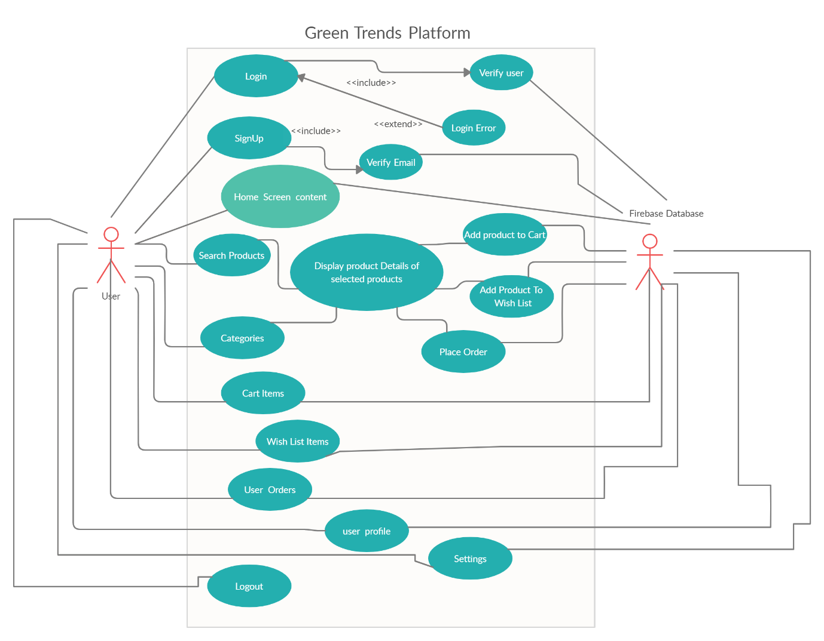

Use Case Diagram: Admin Panel

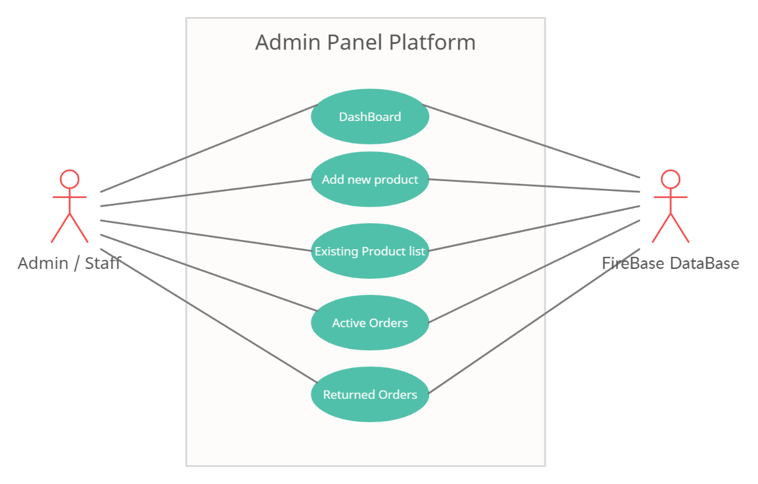

Activity Diagram: GreenTrends

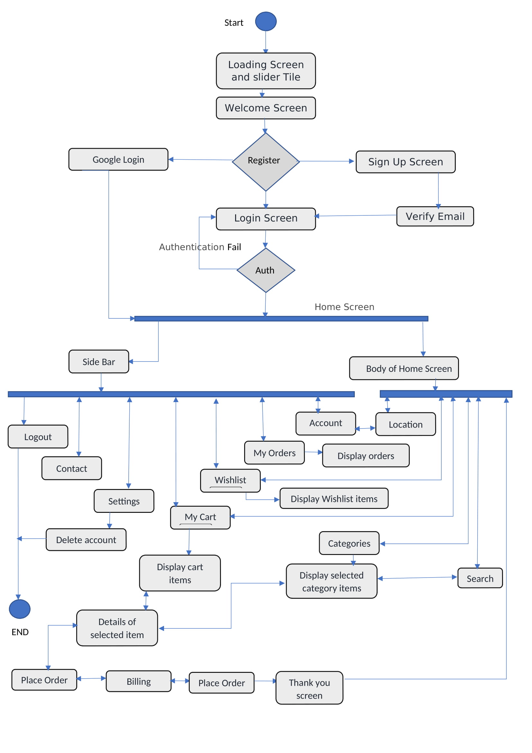

Activity Diagram: Admin Panel

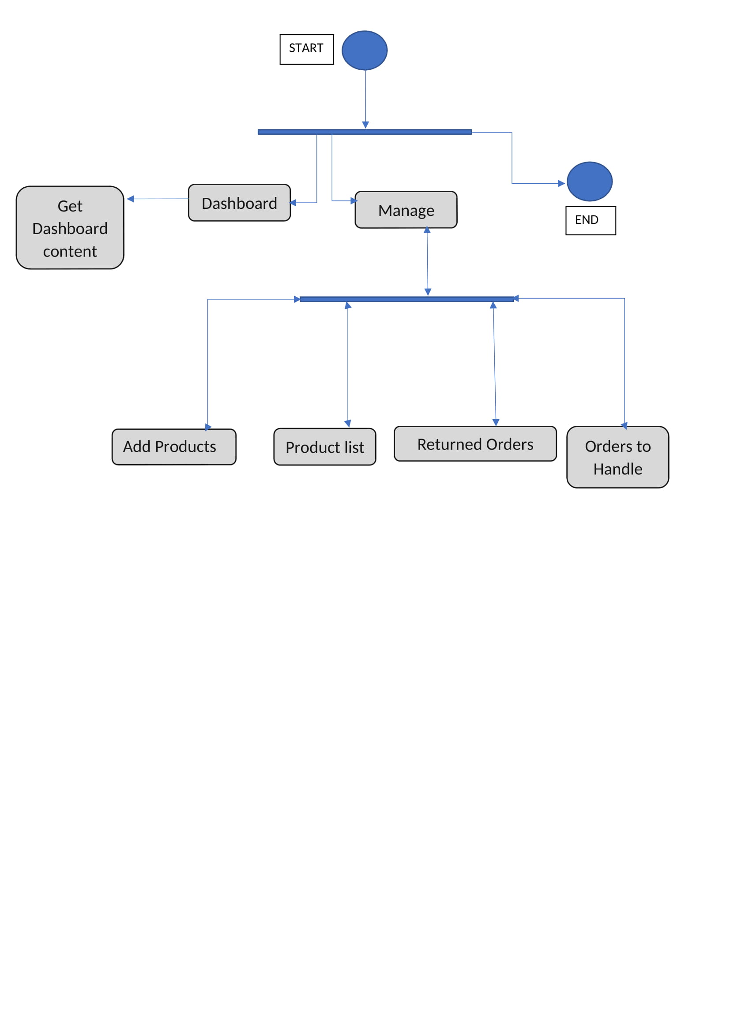

Class Diagram

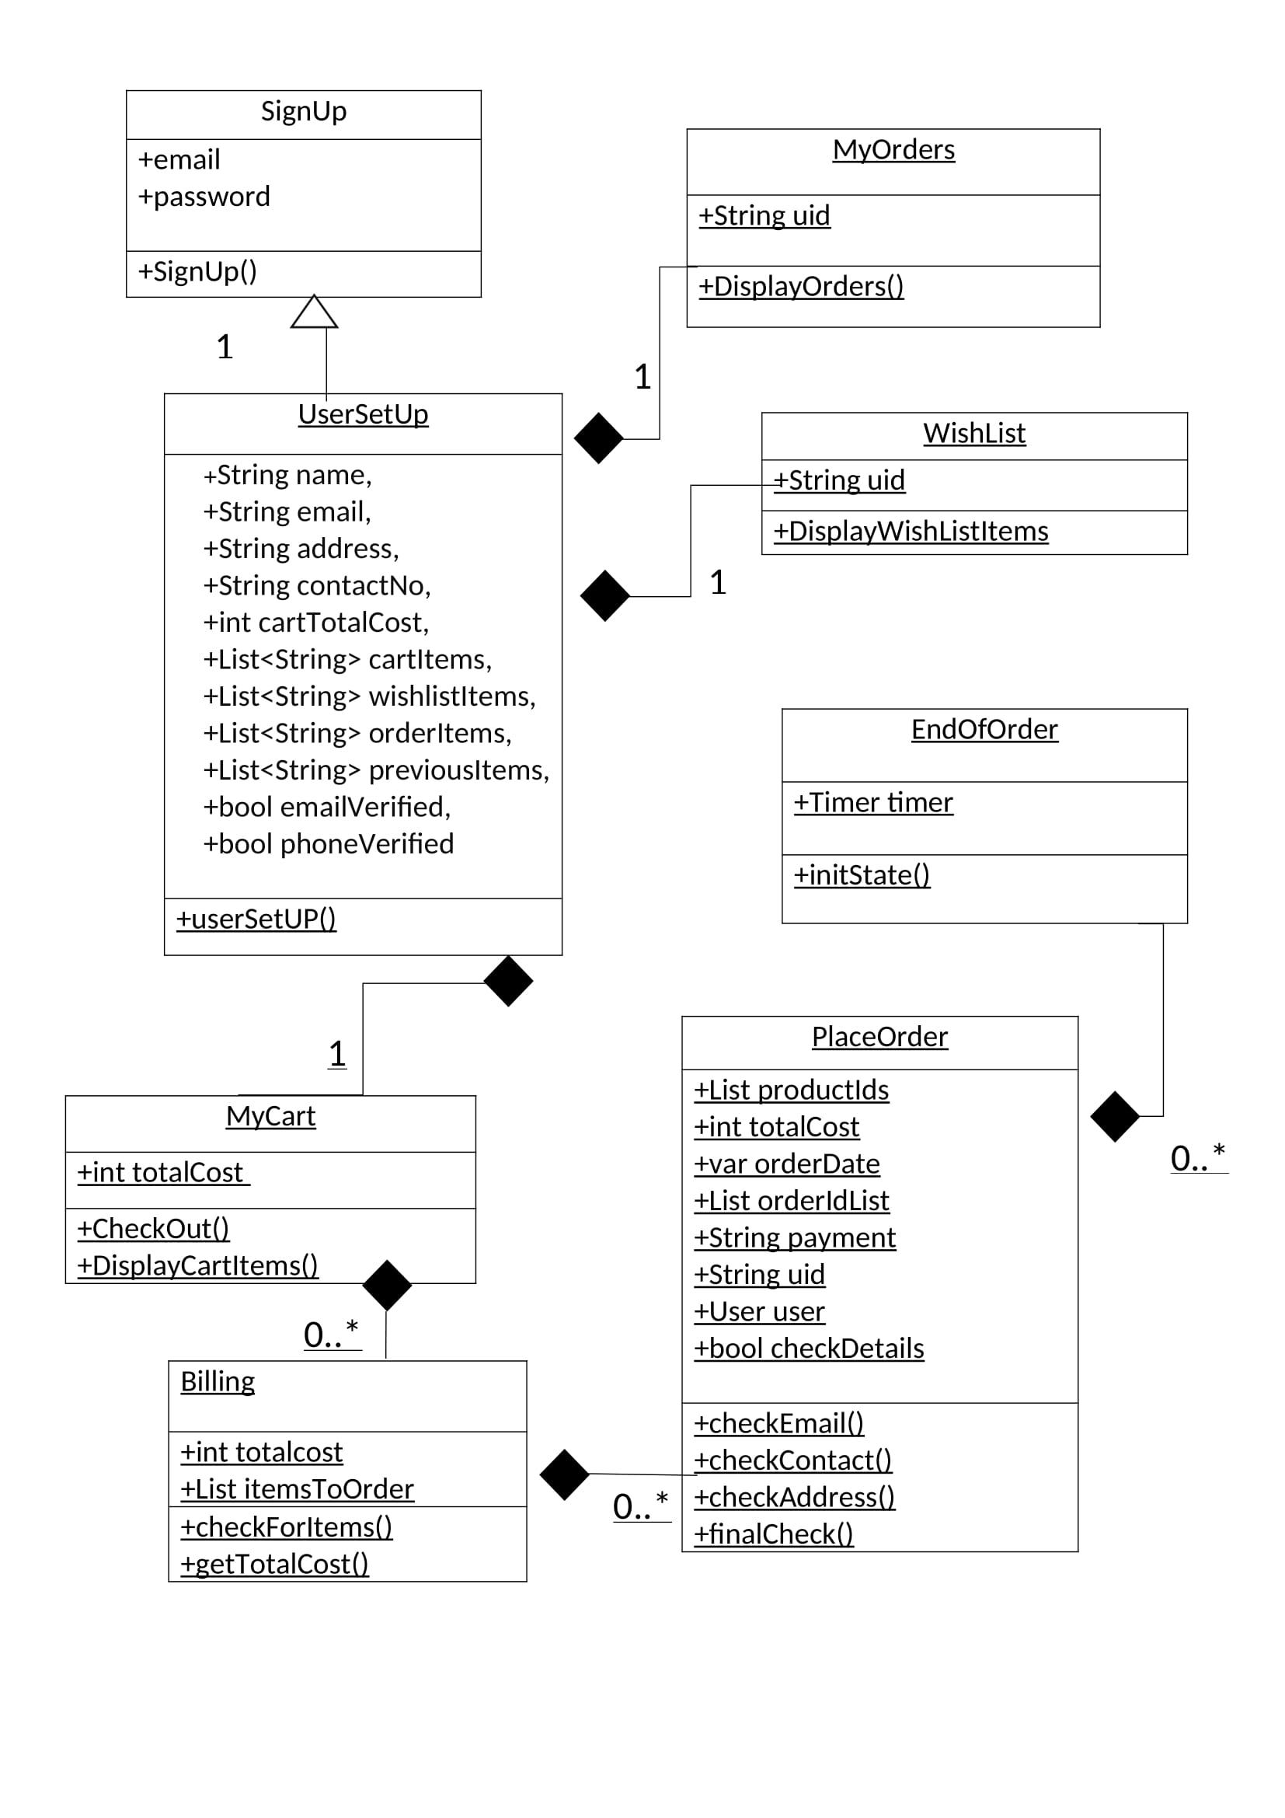

Sequence Diagram:

Place order and view product details

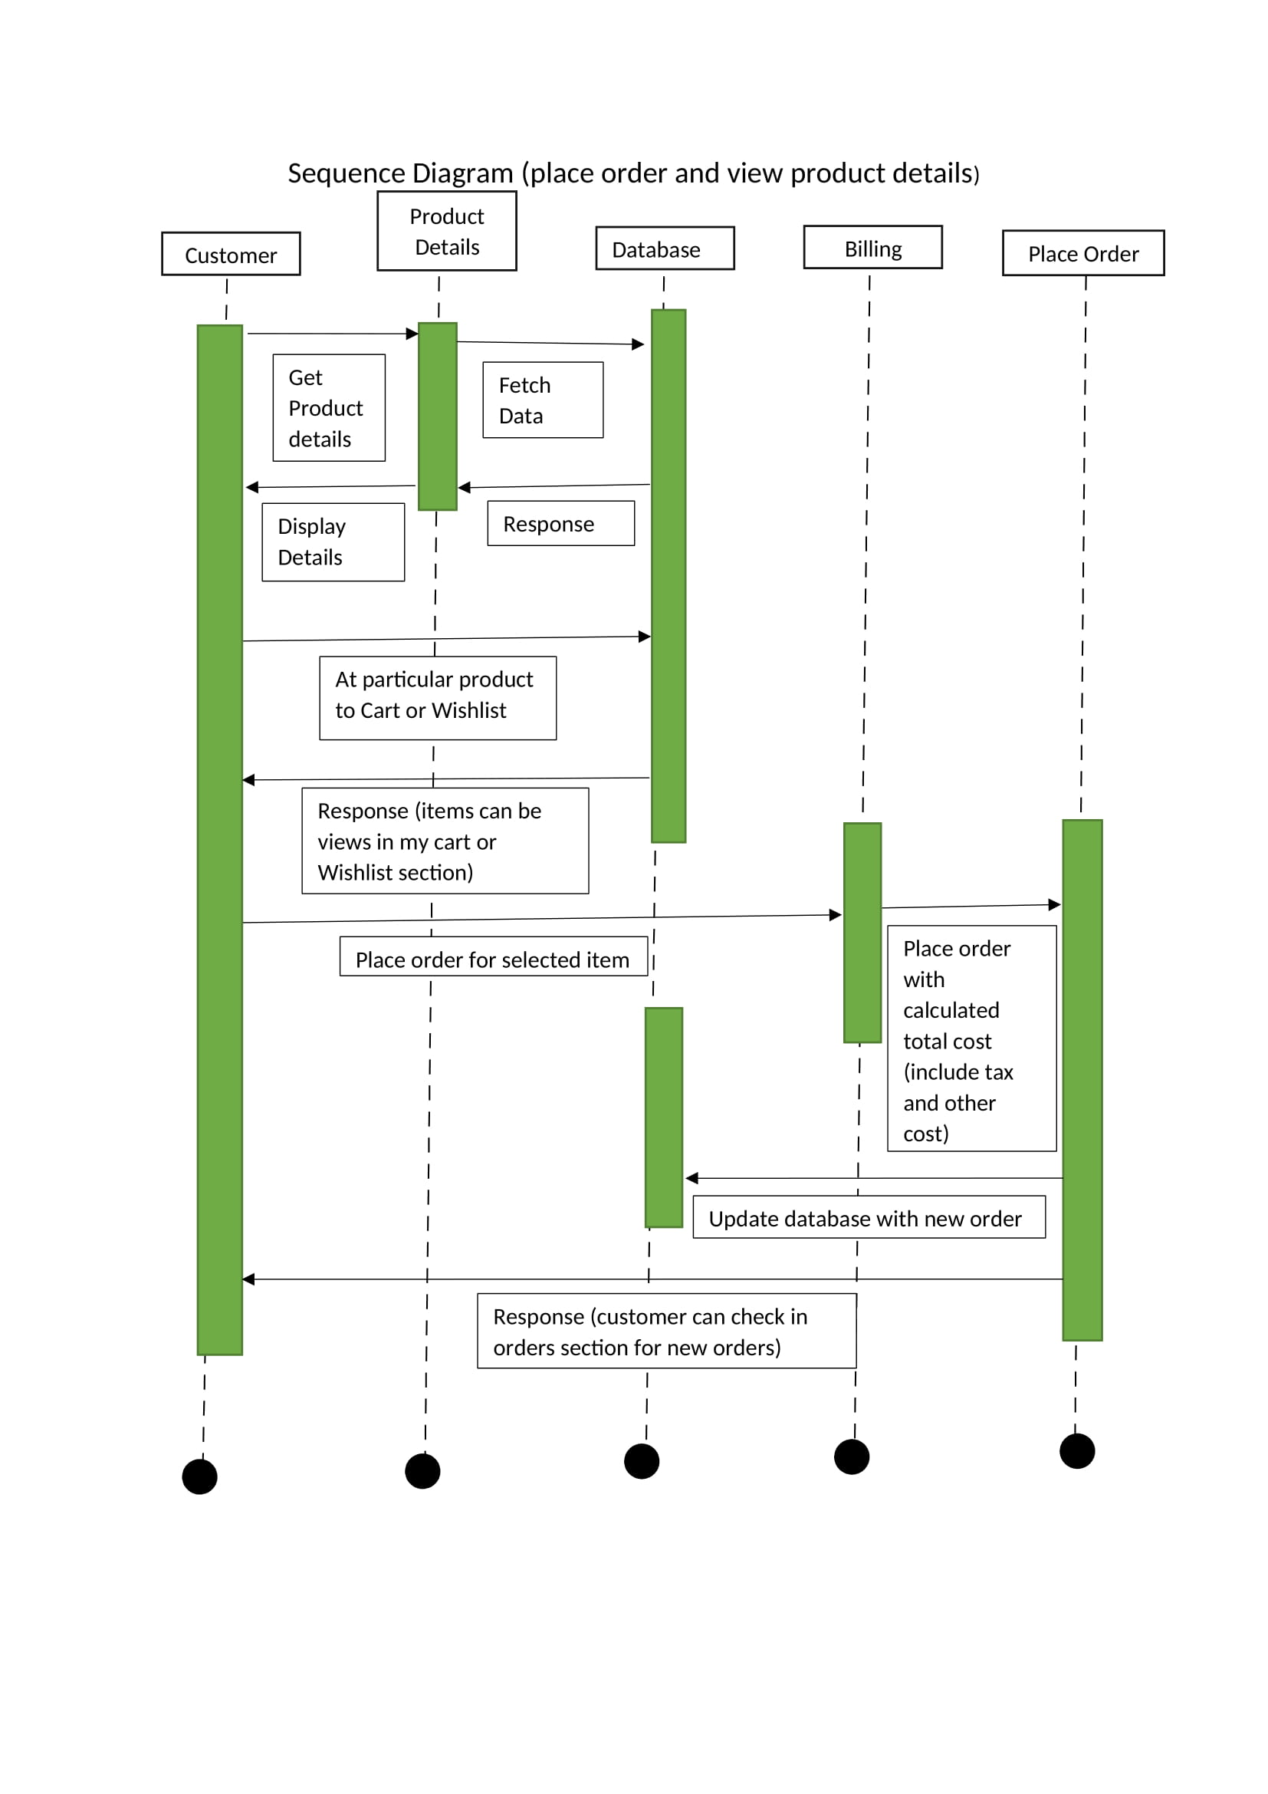

Sequence Diagram:

Register and Login new customer

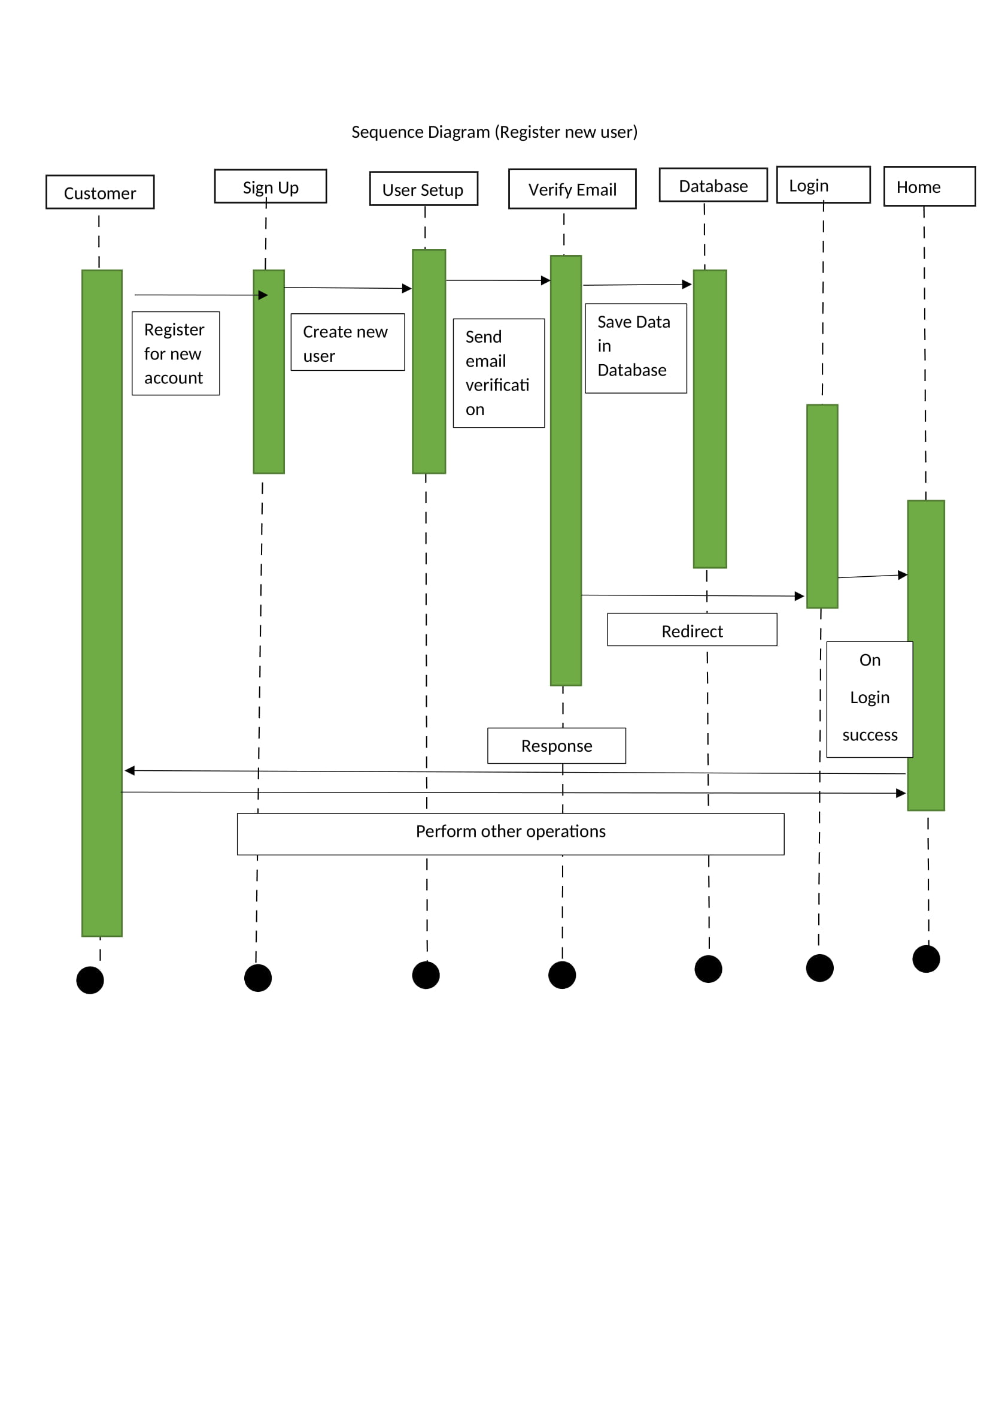

State Diagram: Customer

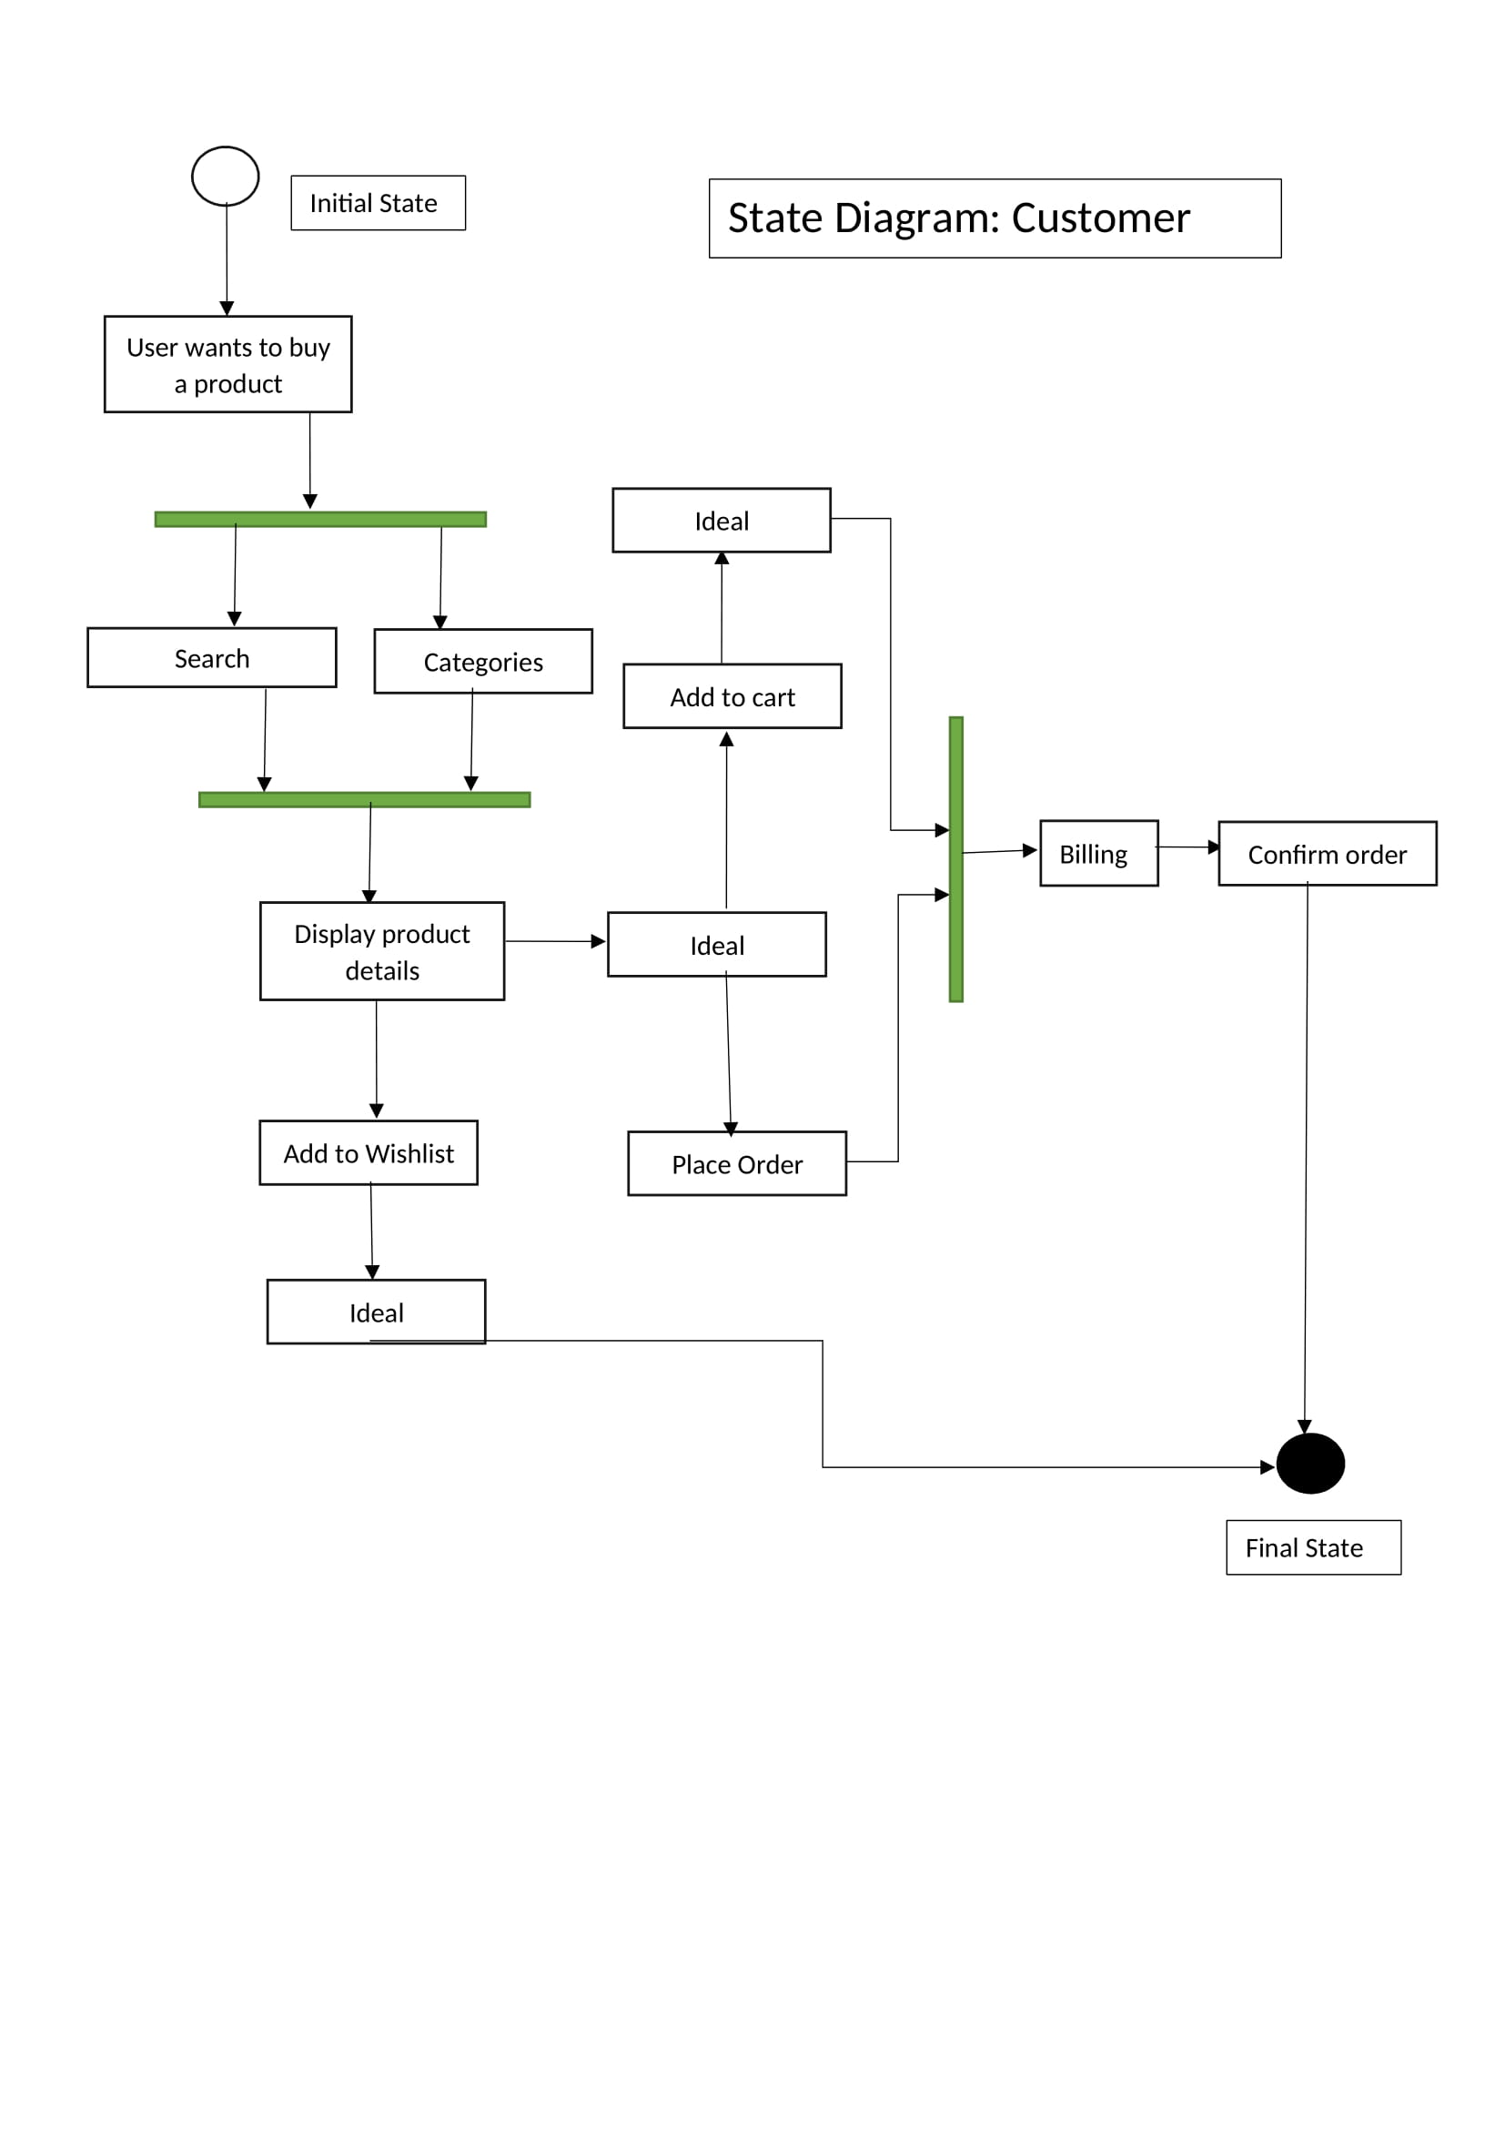

State Diagram: Dynamic user login

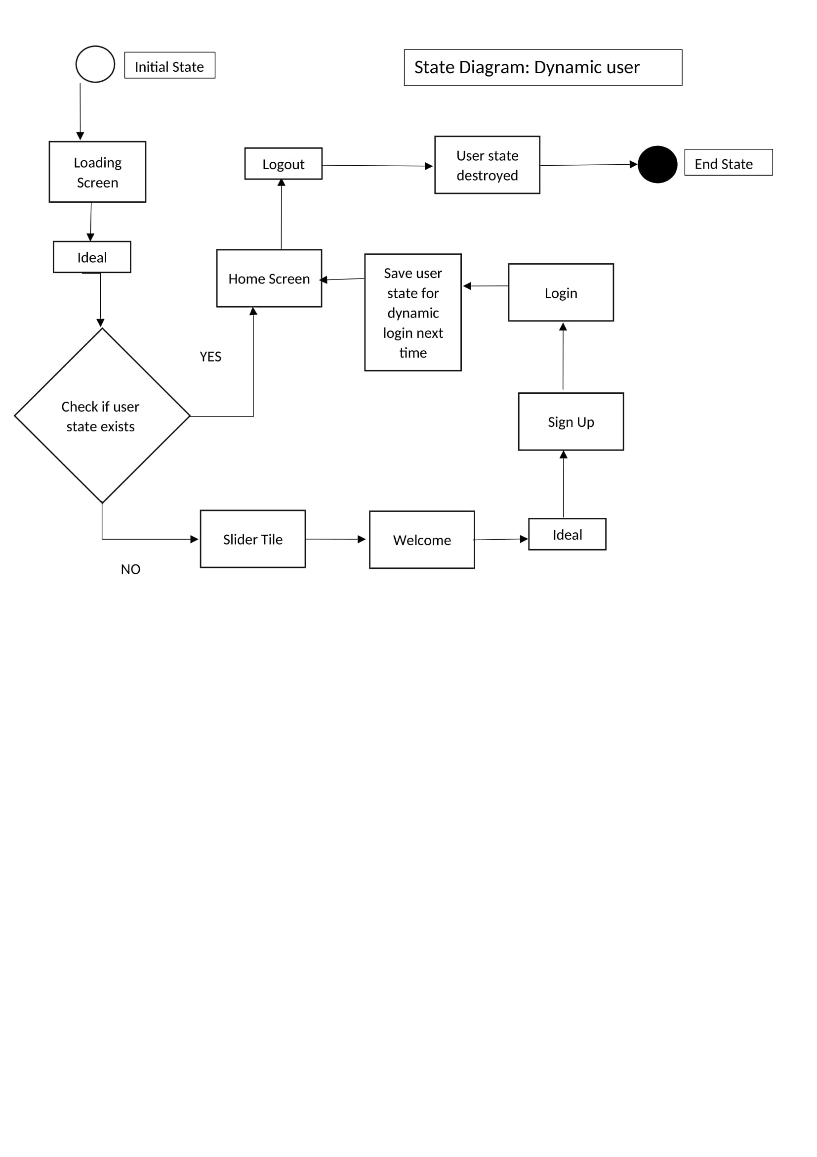

System Design

Component Diagram: GreenTrends

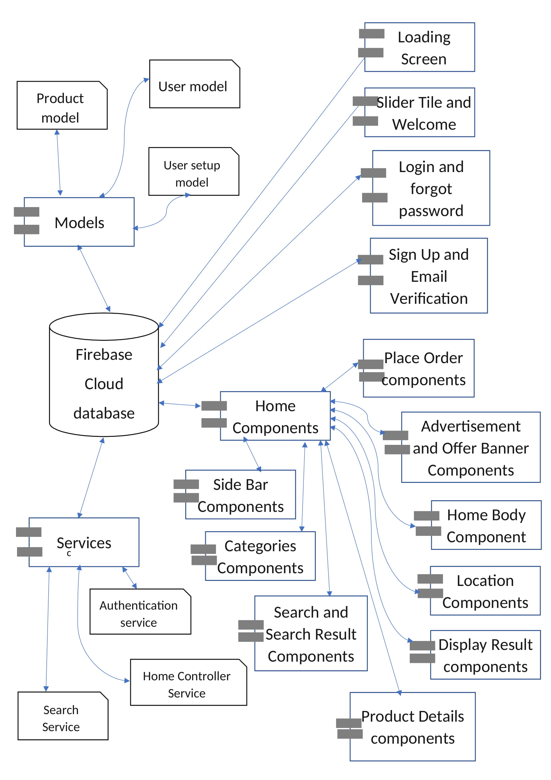

Component Diagram: Admin Panel

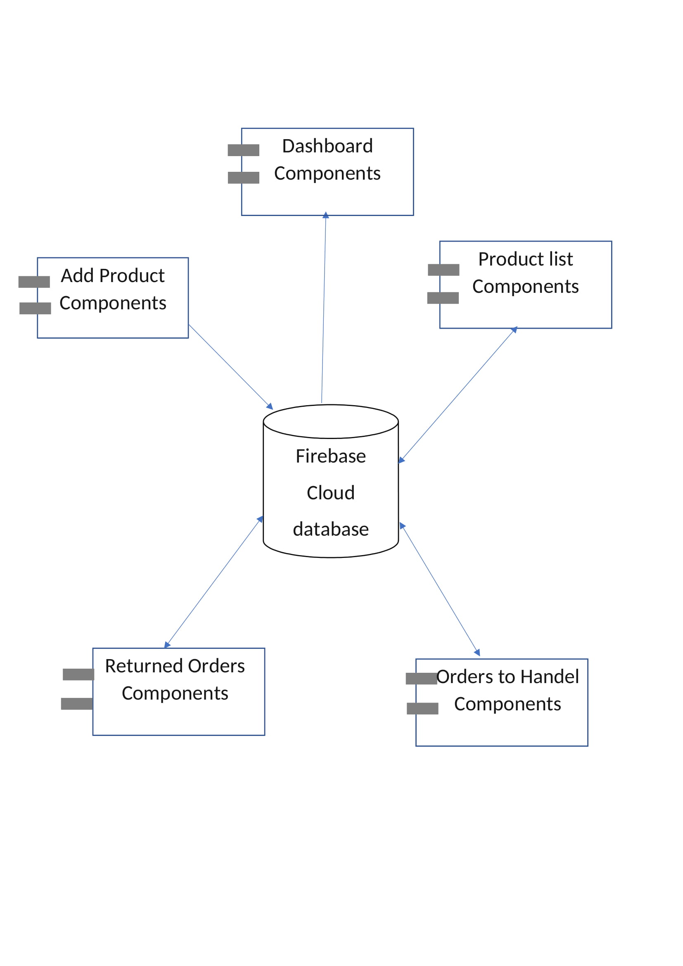

Deployment Diagram

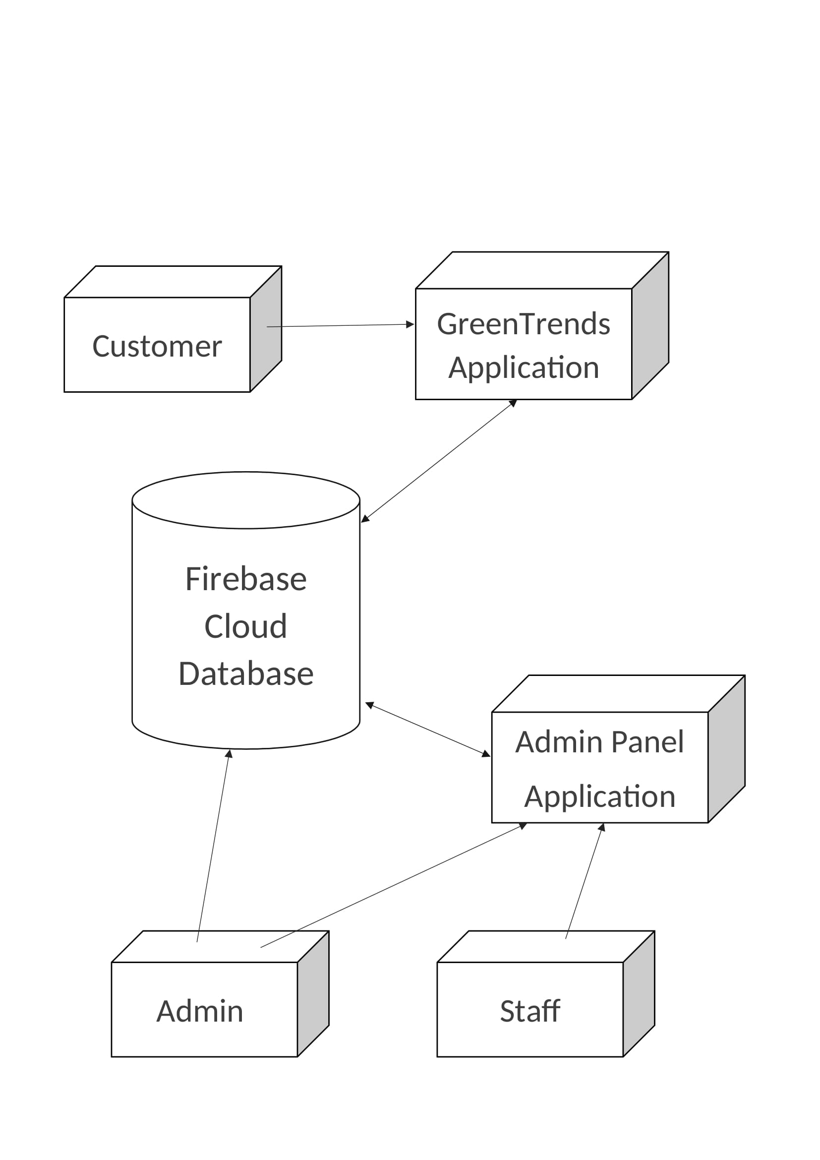

System Coding

Database Design

Firebase Console:

We are using firebase for backend. Firebase provides us with an admin panel which has multiple functions from application information to database. Firebase is a NoSQL database or tree database which does not need tables to be dependent on each other.

“GreenTrends” and “Admin Panel” both are connected with Firebase console

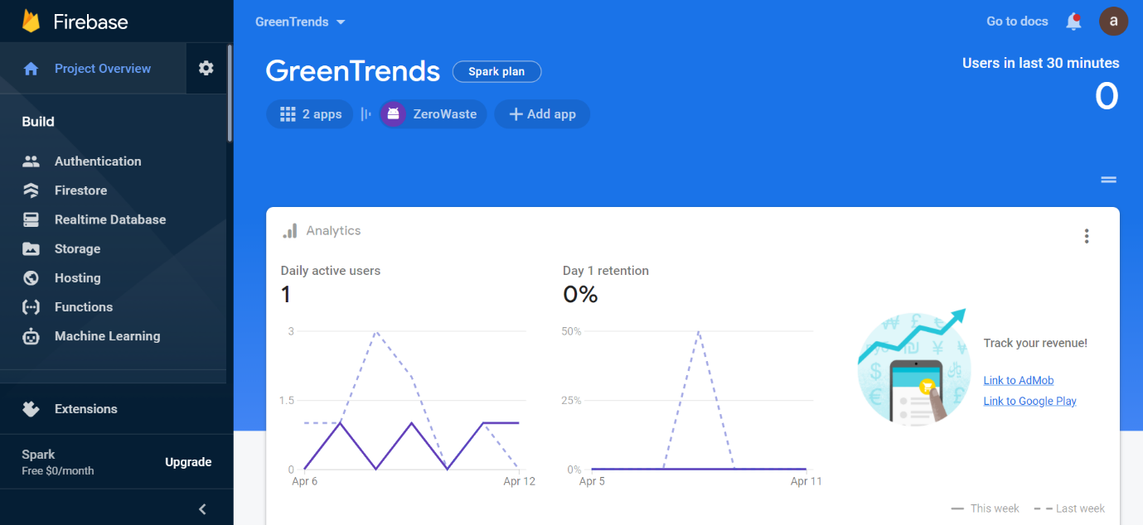

Firebase Authentication:

In authentication section we get customers login information.

The “G” represents the user has logged in by google account.

UID is really important, we represent, perform operation and save customers data based on their UID

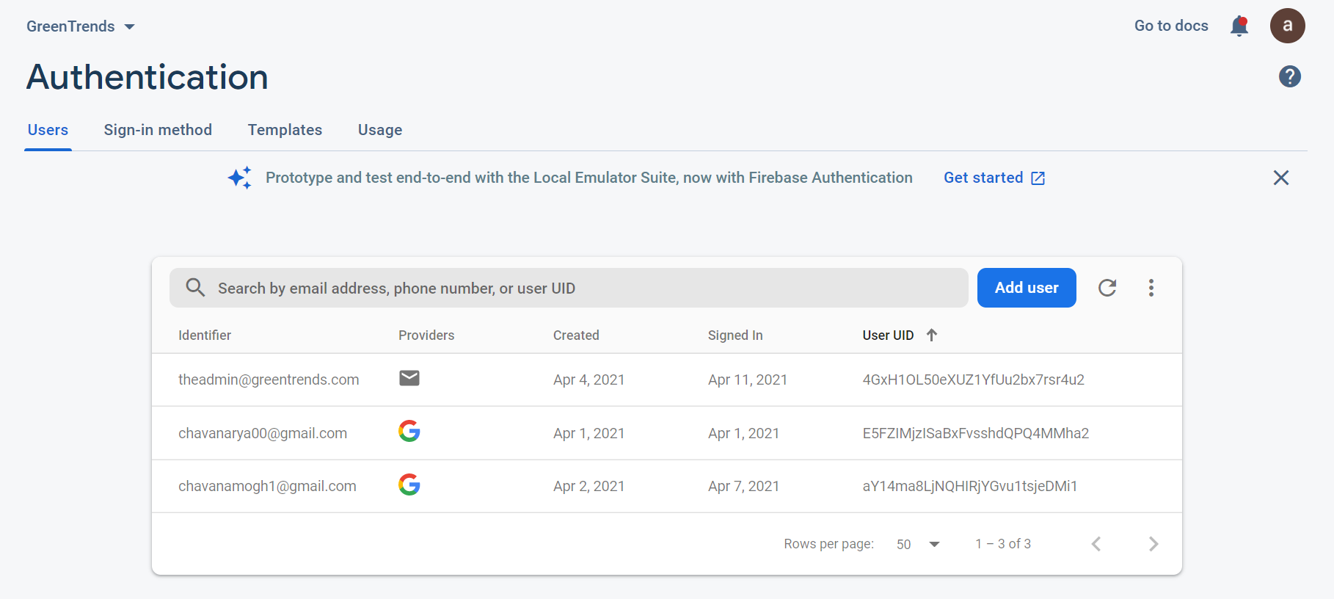

Firebase Cloud: Users Collection

When ever a new user is registered a new document is created in “users” collection. The document ID is same as that user’s UID.

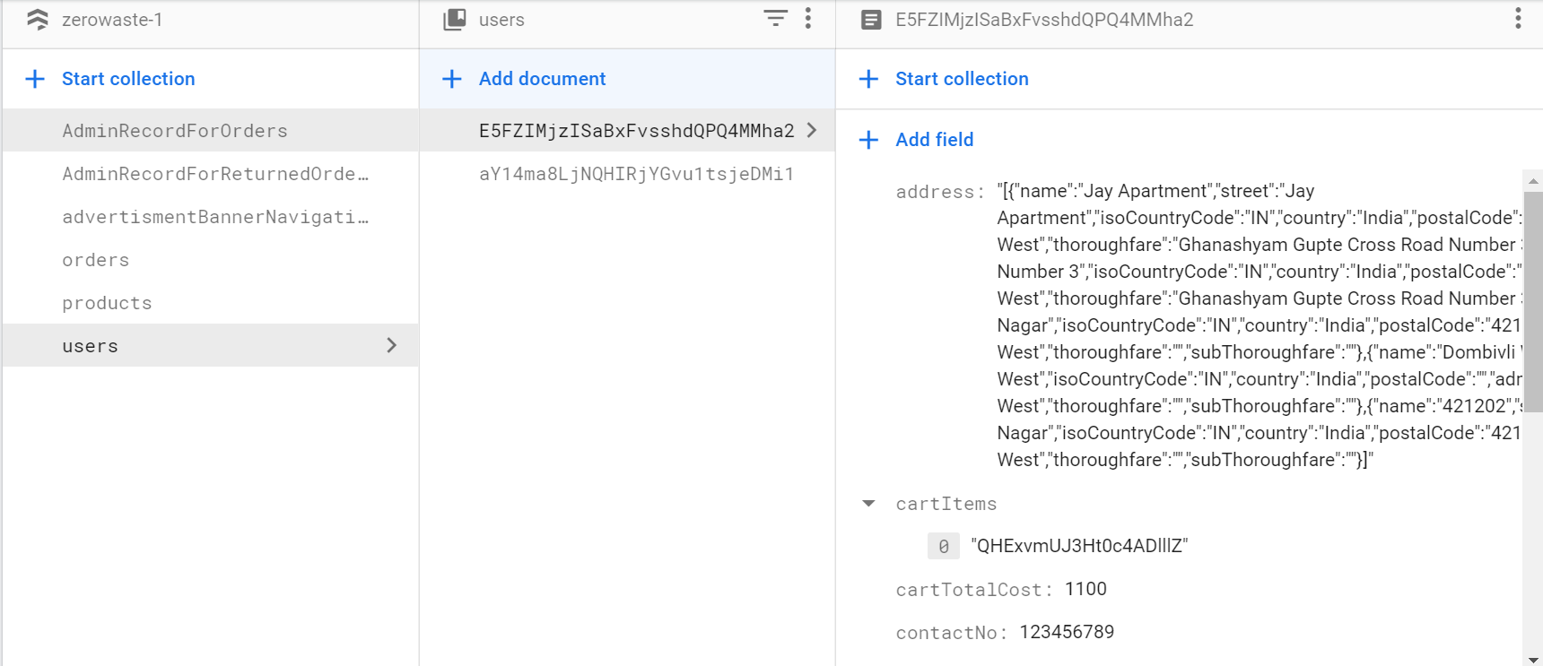

In user collection we save user selected products with their product ids in “Cart-Items” and “Wishlist-Items”.

In “Order-Items” section, we save user order with order ids generated by GreenTrends Platform.

Following are the “user” collection fields

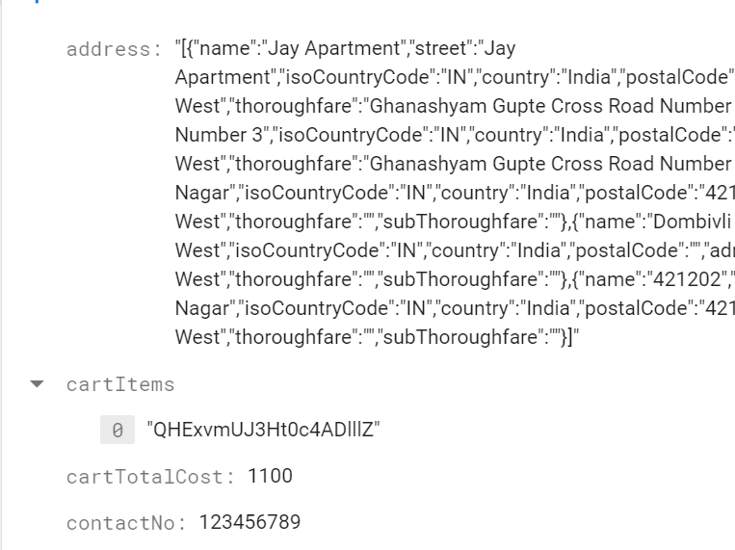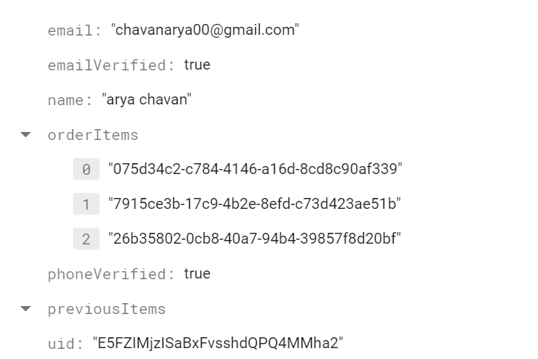

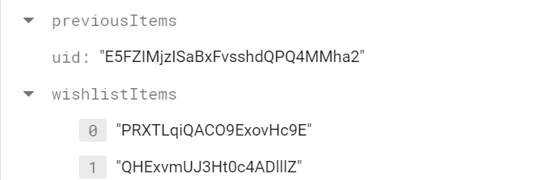

Firebase Cloud: Products Collection

In products collection all the documents are assigned random IDs. The products can be differentiated based on their product tag (product belongs to which category example: MEN).

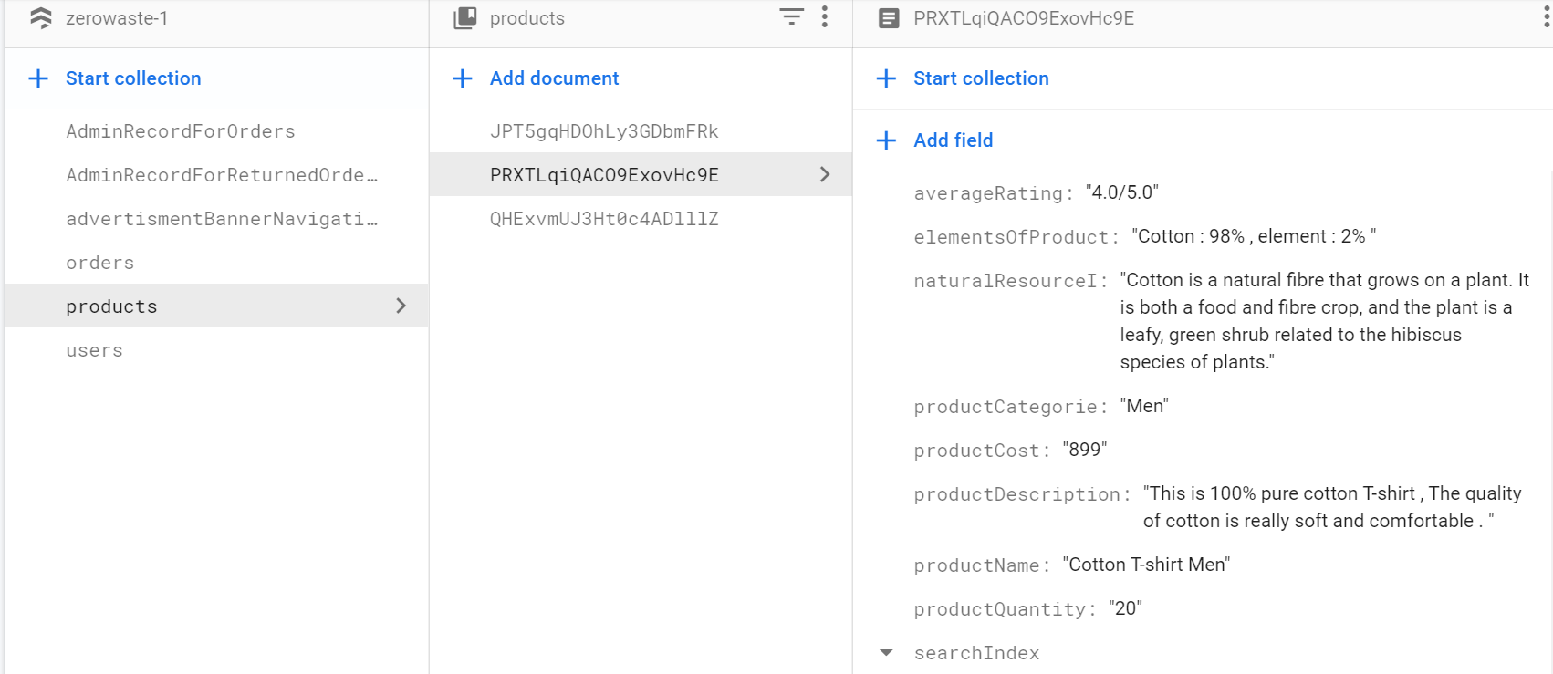

We can add new products to database from admin panel in “ADD PRODUCTS”

Section.

Following are the “products” collection fields

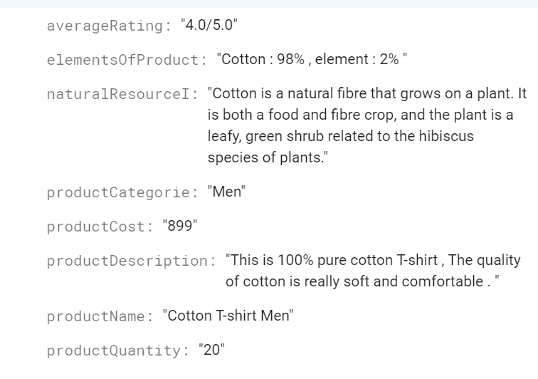

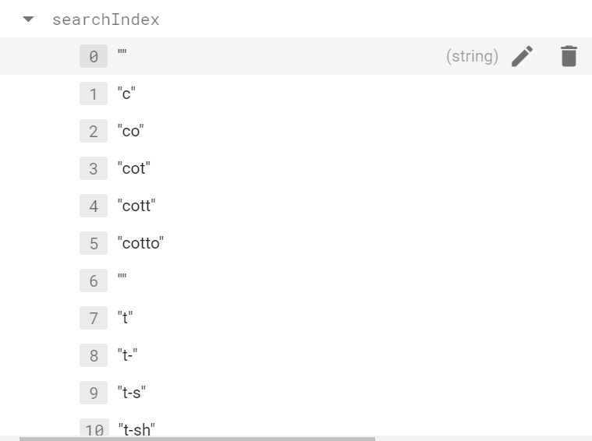

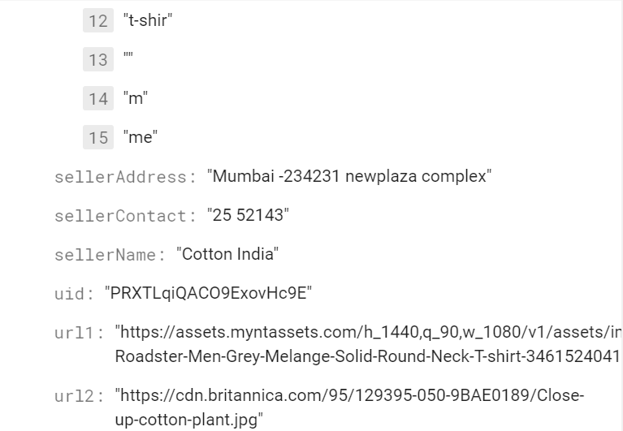

Firebase Cloud: Orders Collection

In orders collection, we save the record of every customers orders as a backup.

When customer places and order, Platform will create a new document with user UID as document ID 1 >In which we will create another collection named “user orders” > In which, every time user or customer places an order we will generate new document and store all that order details in that documents.

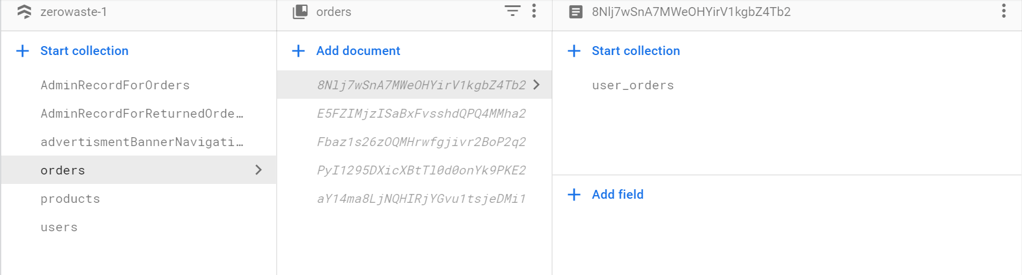

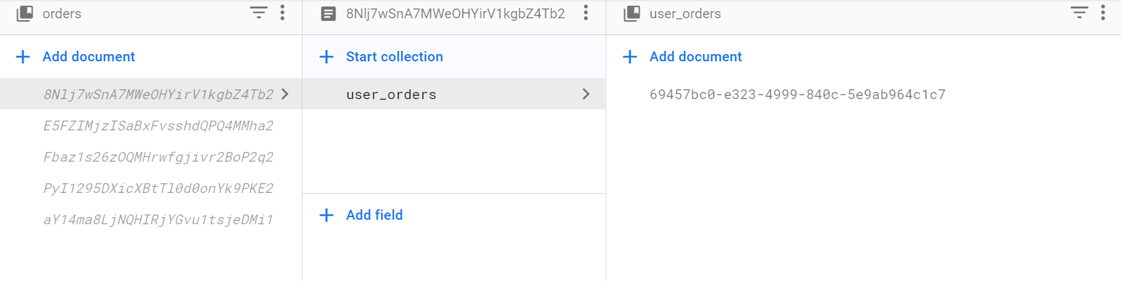

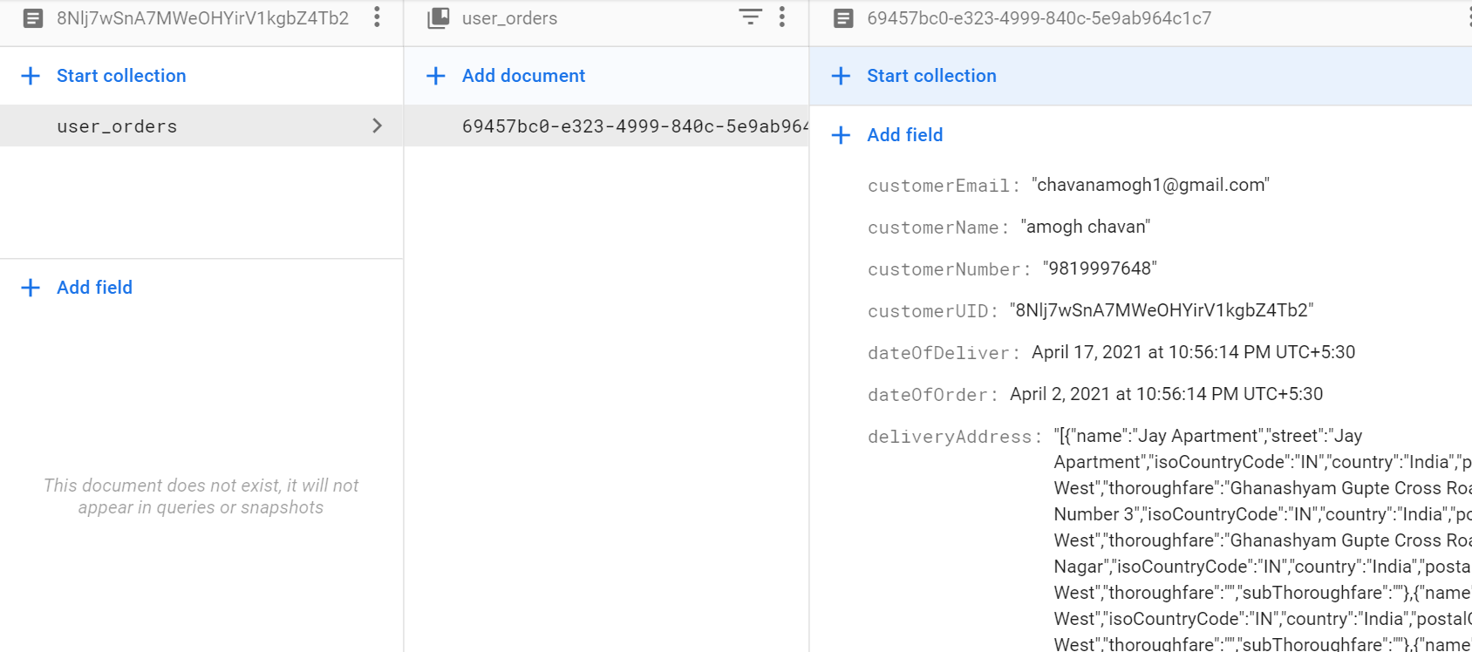

Following are the “orders” collection fields

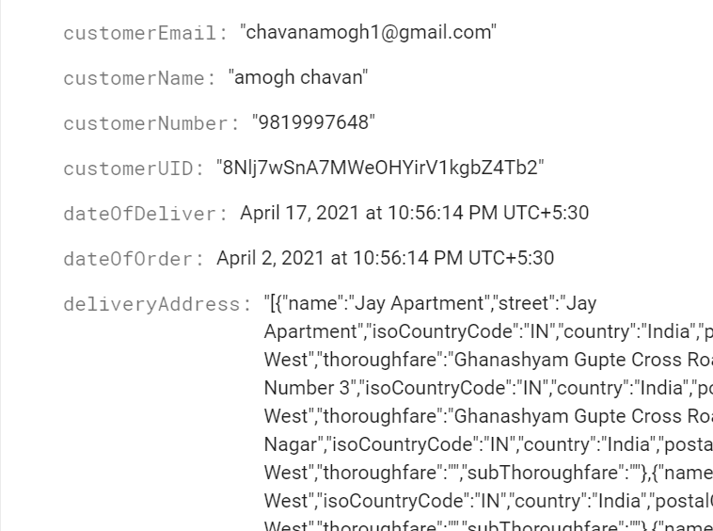

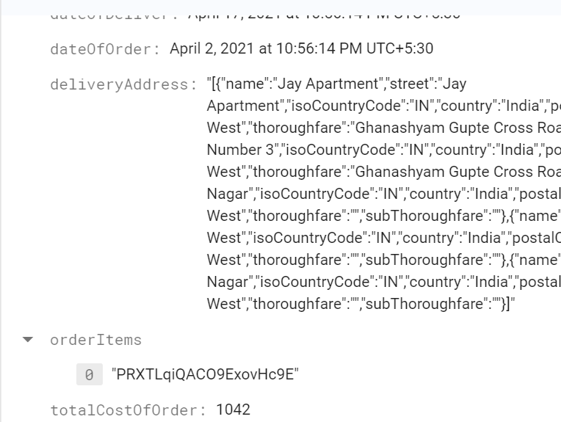

In order Items the string which we store is the ID for the products which user or customer has selected.

Firebase Cloud:

Admin Record: Returned Orders Collection

In this collection, platform stores the record of which are orders are to be returned.

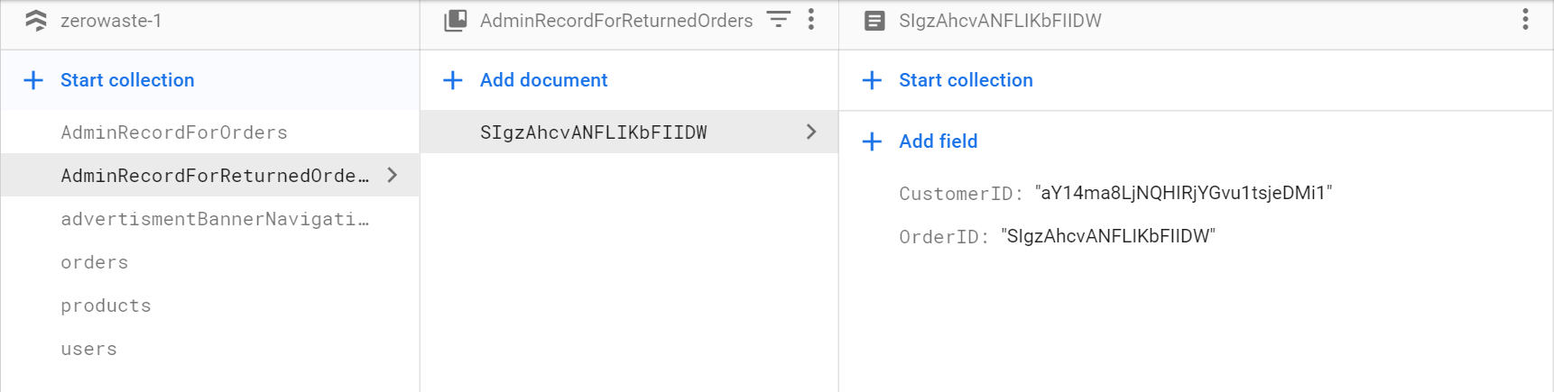

Firebase Cloud:

Admin Record: Customer Orders Collection

In this collection, we have another copy of all customer orders, the collection is created for internal operations performed by the staff / Admin on the active orders

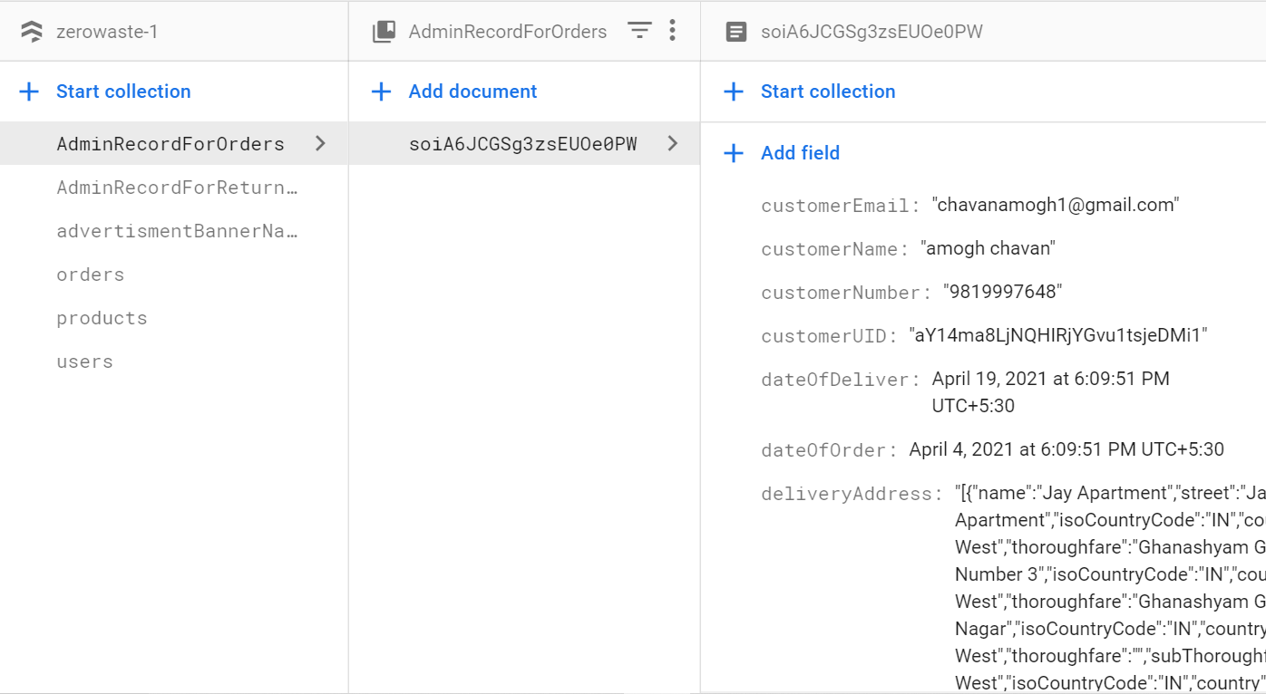

Firebase Storage:

Advertisement images stored in backend

In this folder we save all the images we want to display on our main app home screen.

300 x 300 image size is recommended for proper display.

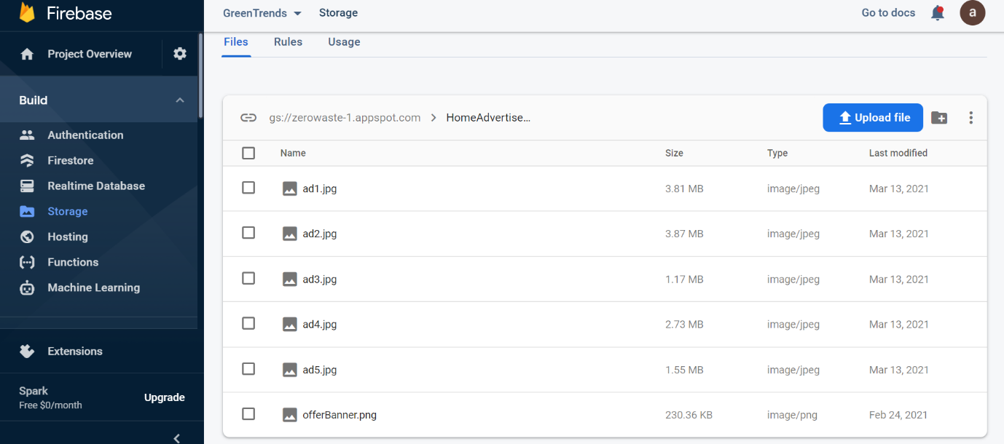

Program Description with Naming Conventions

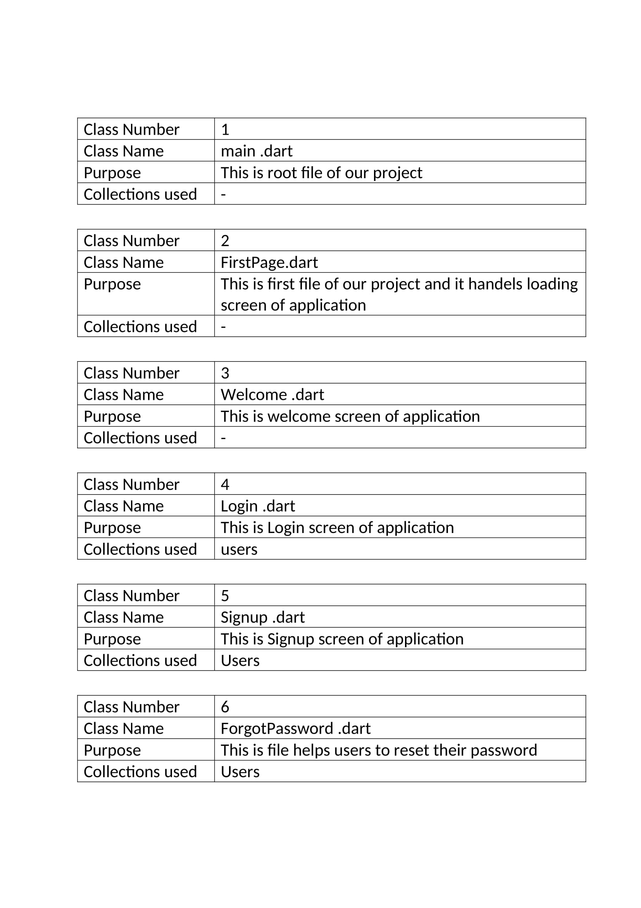

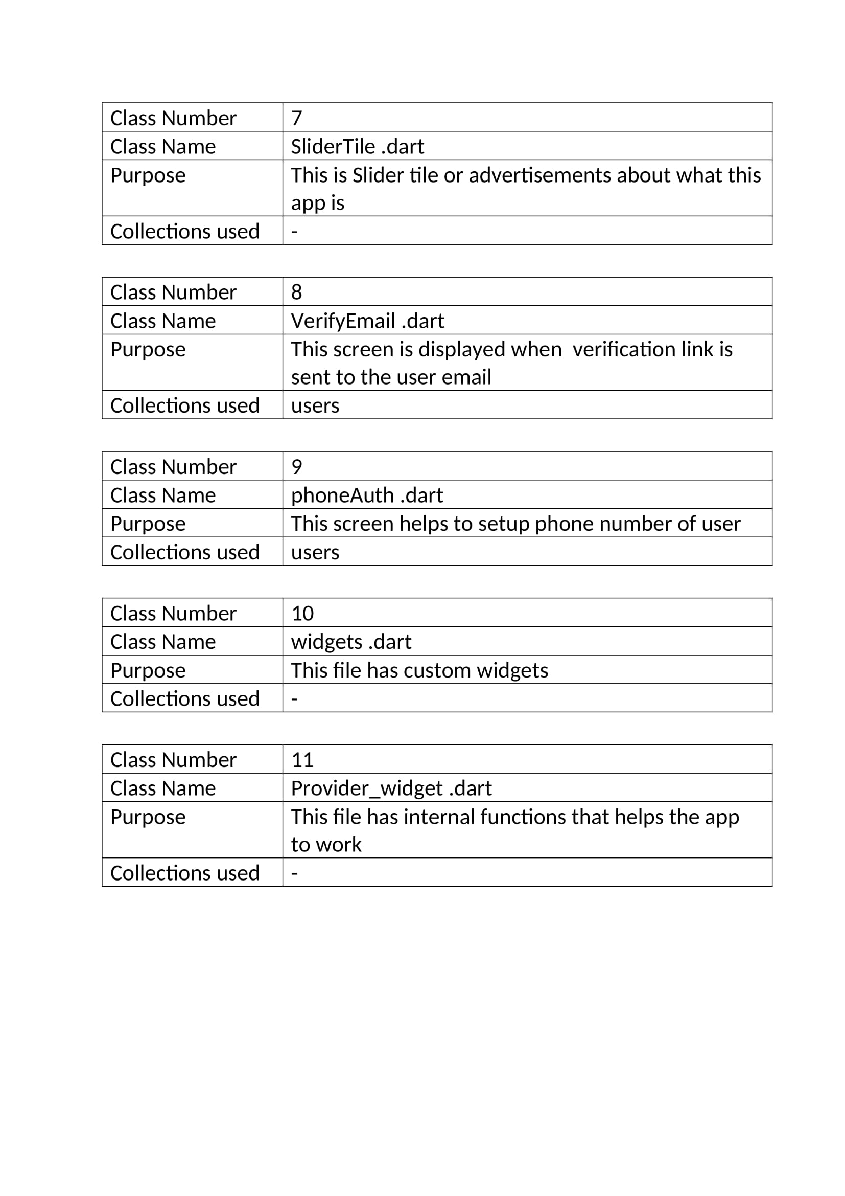

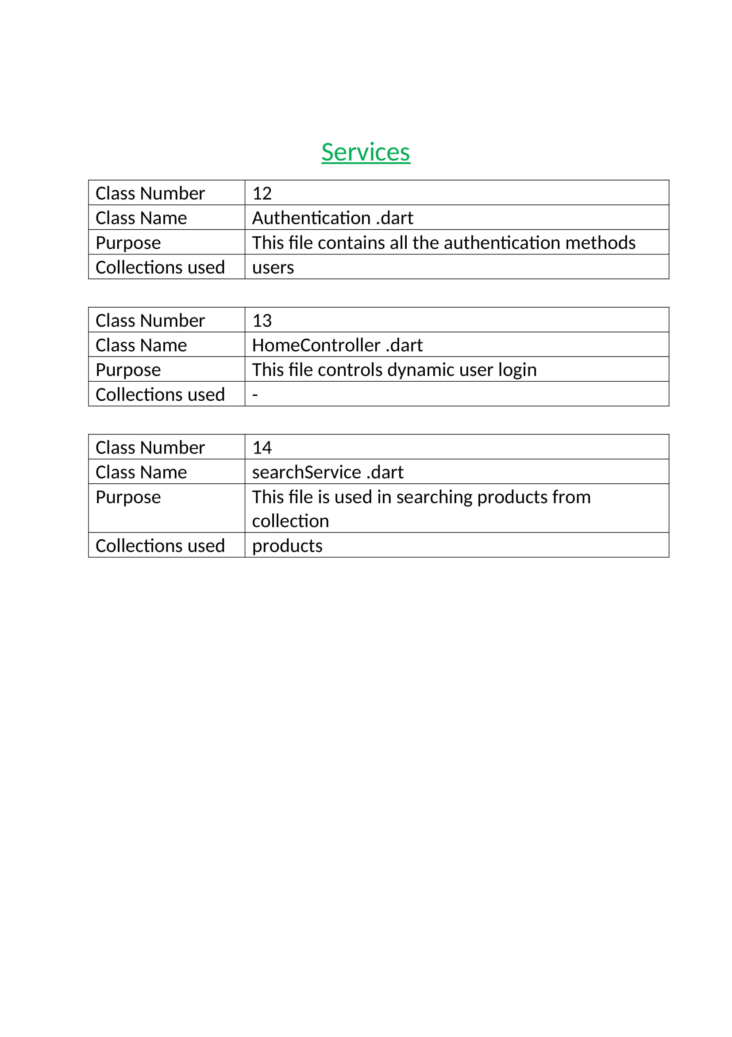

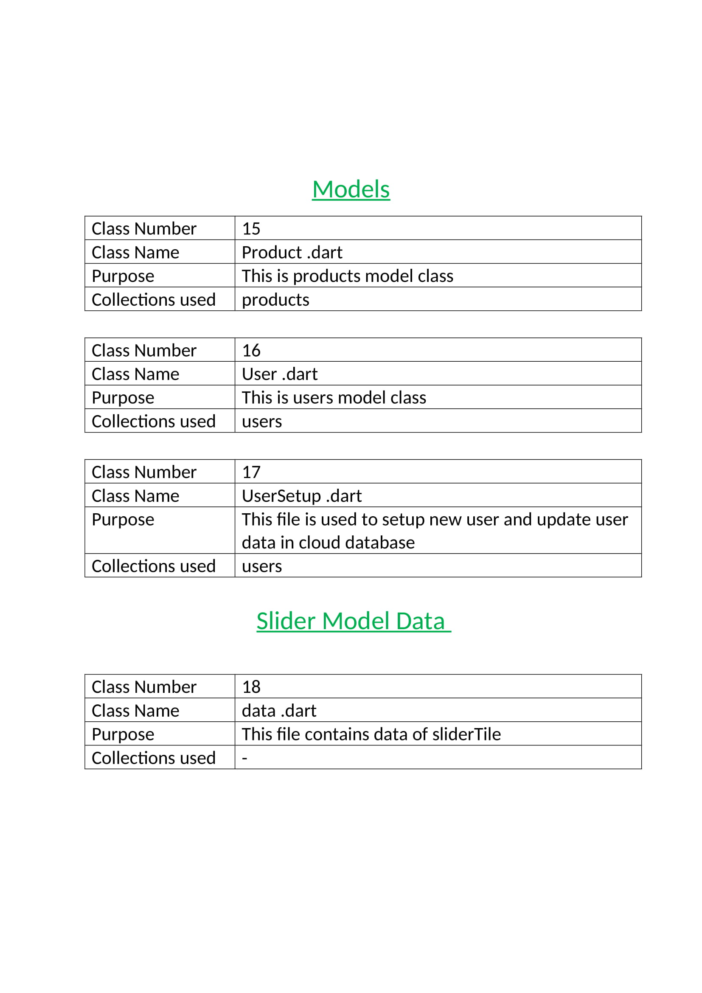

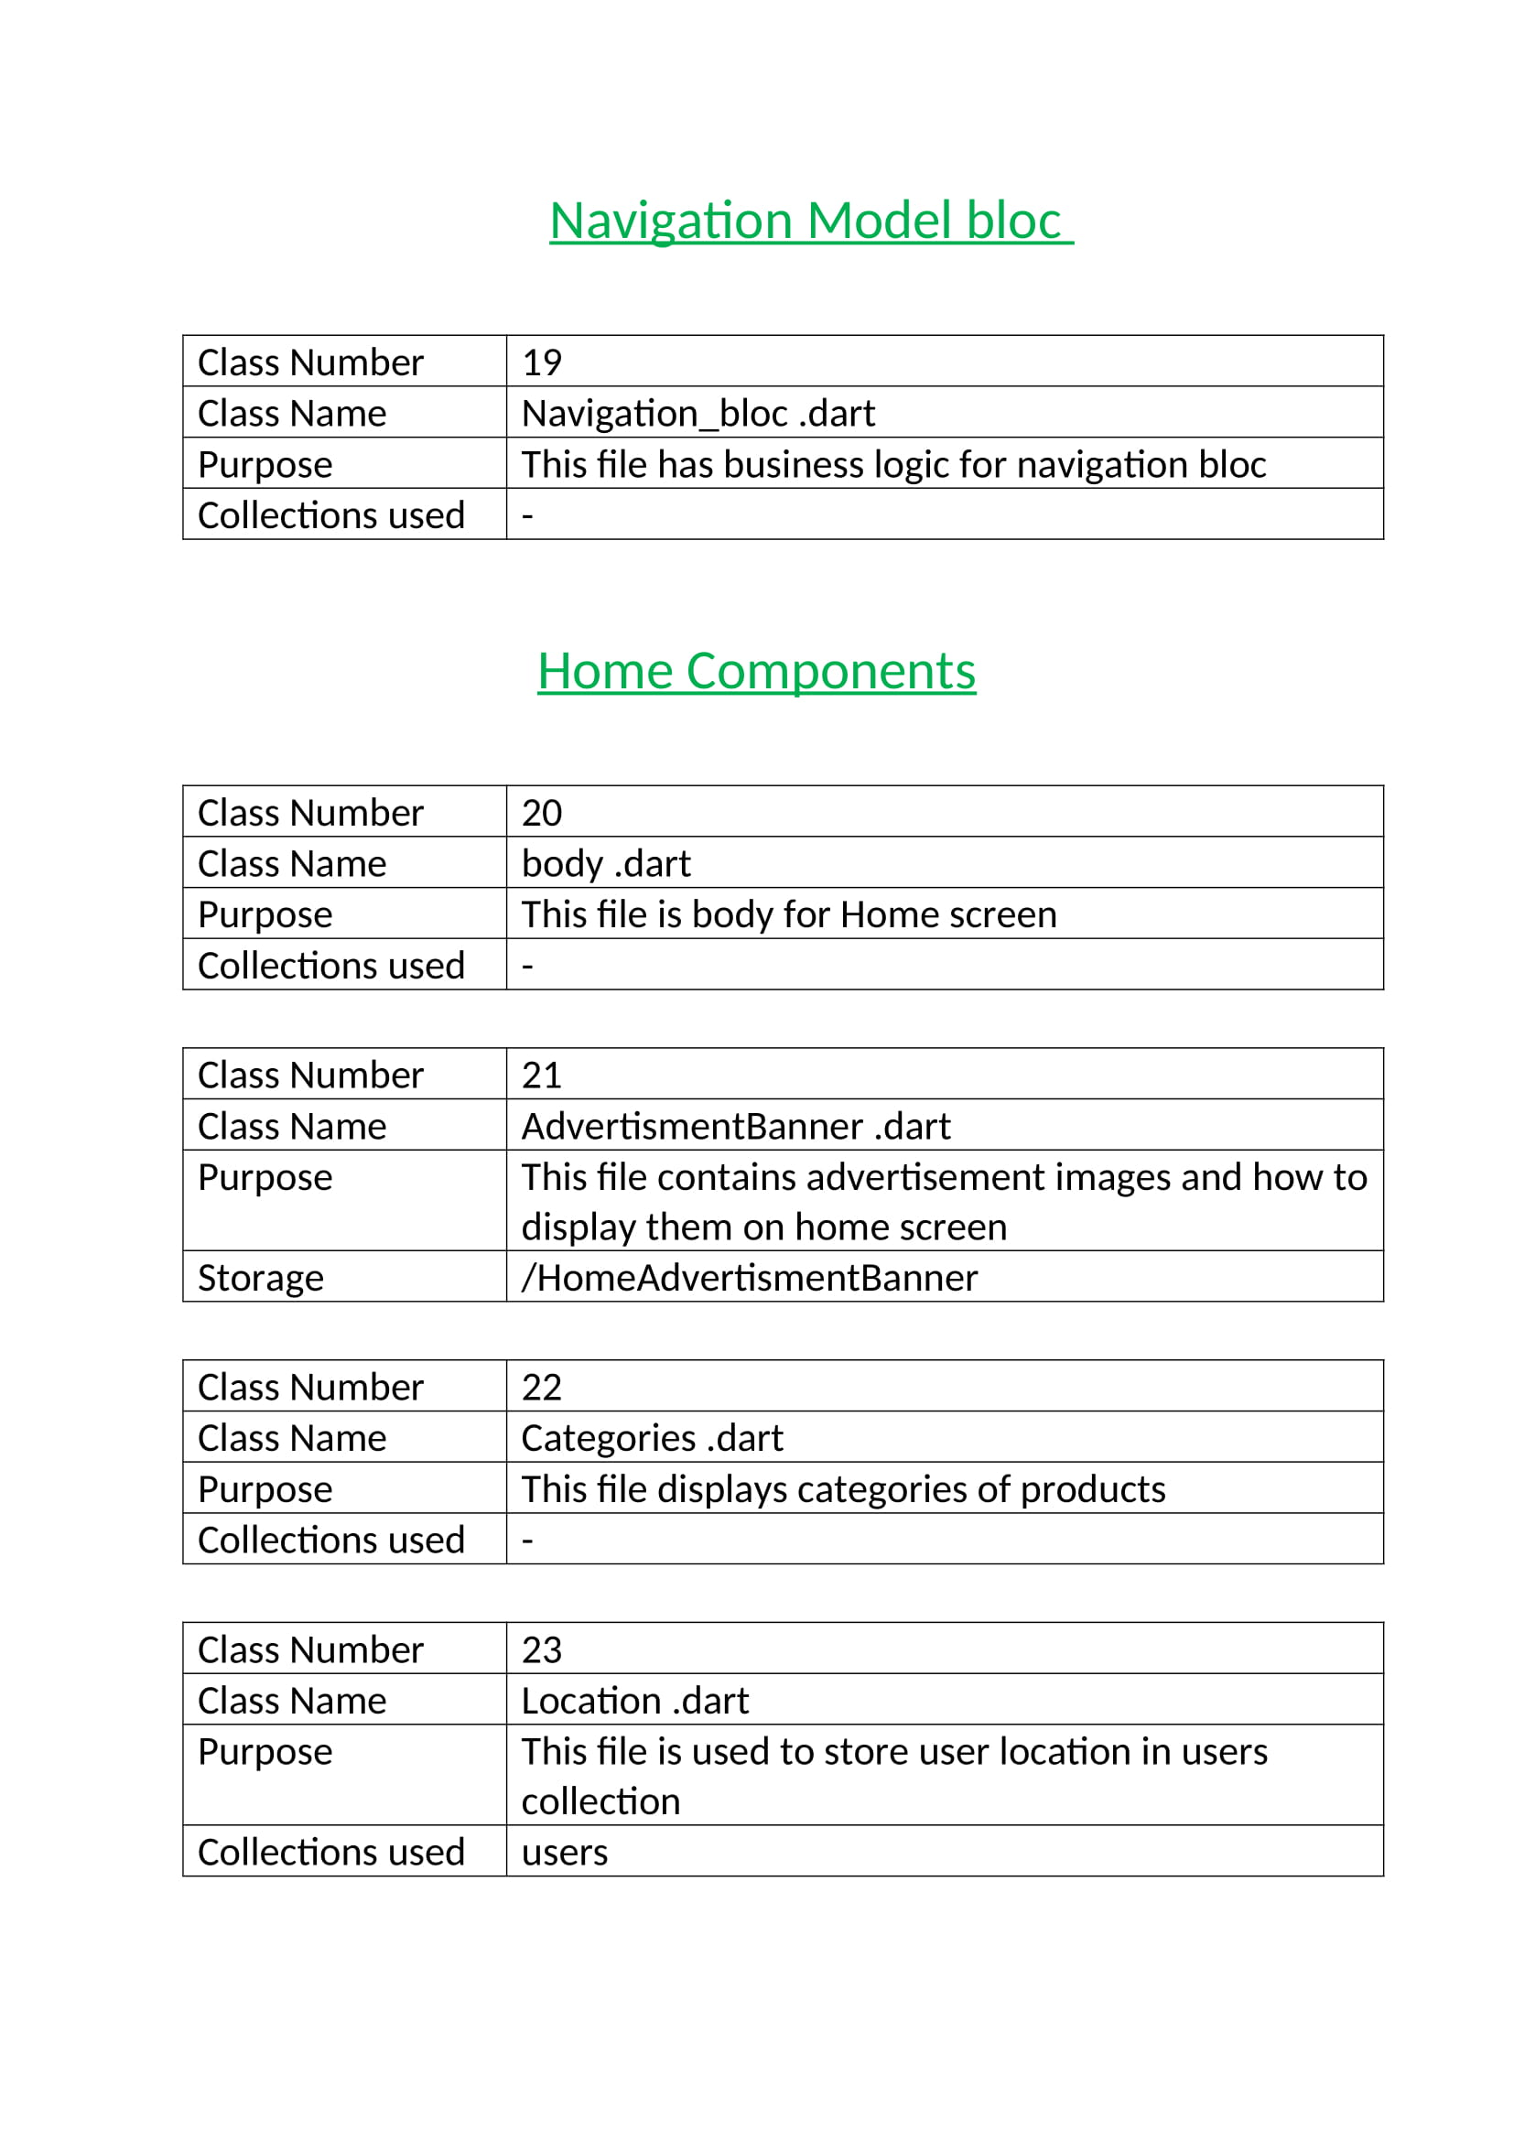

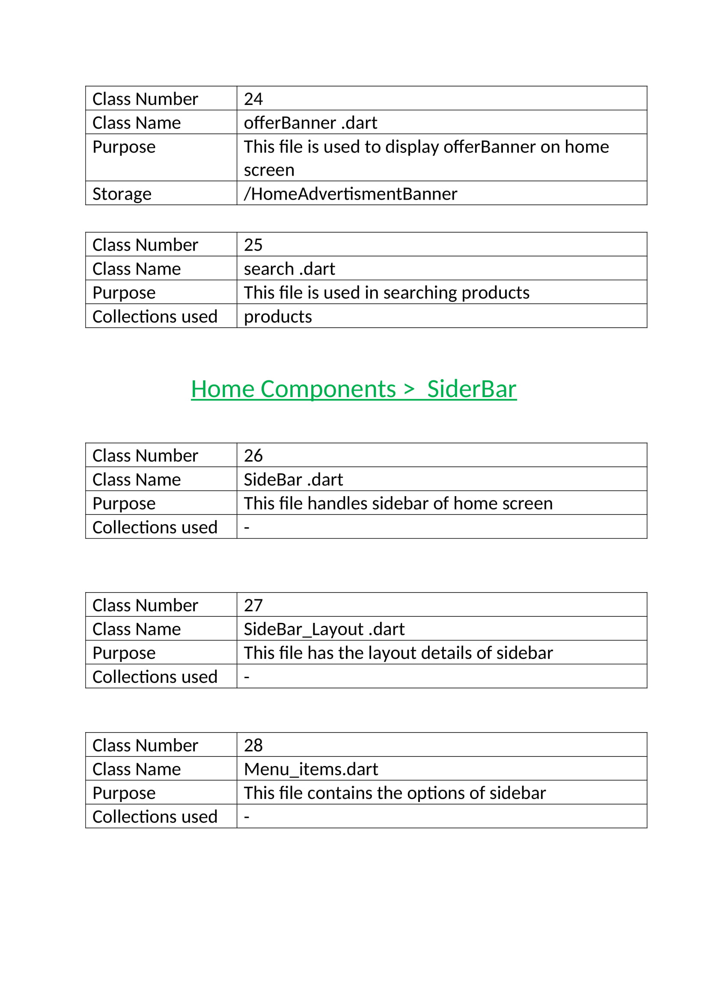

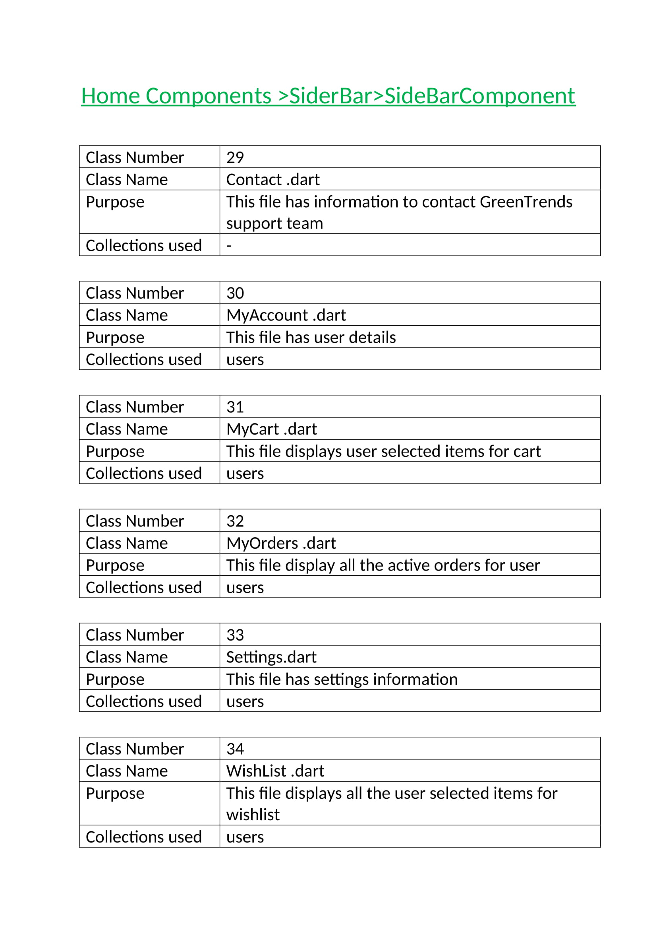

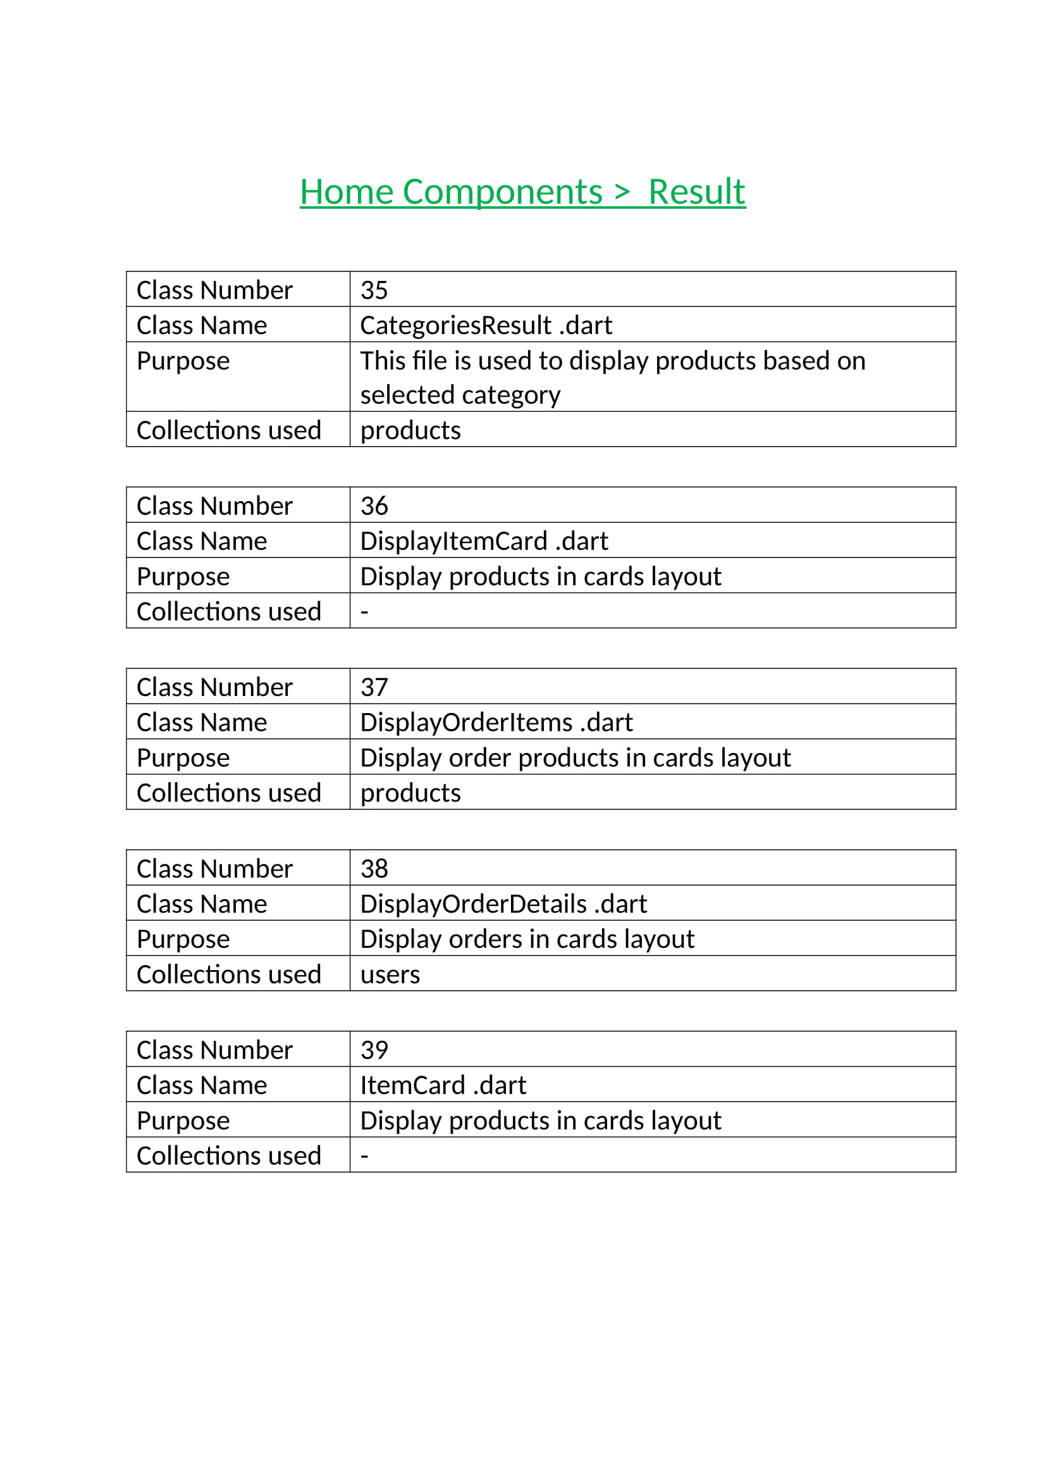

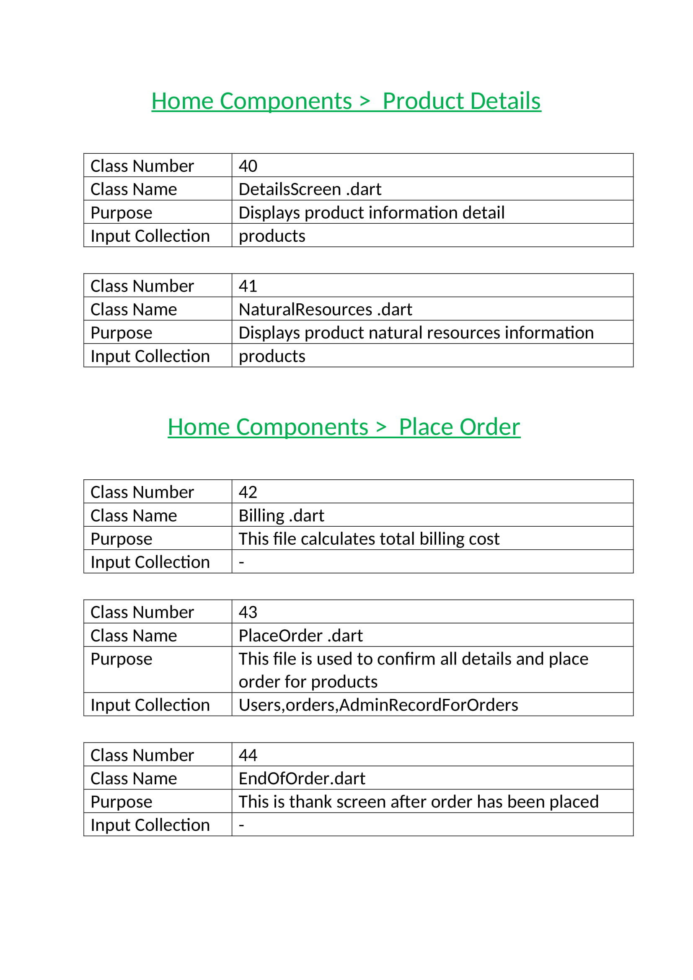

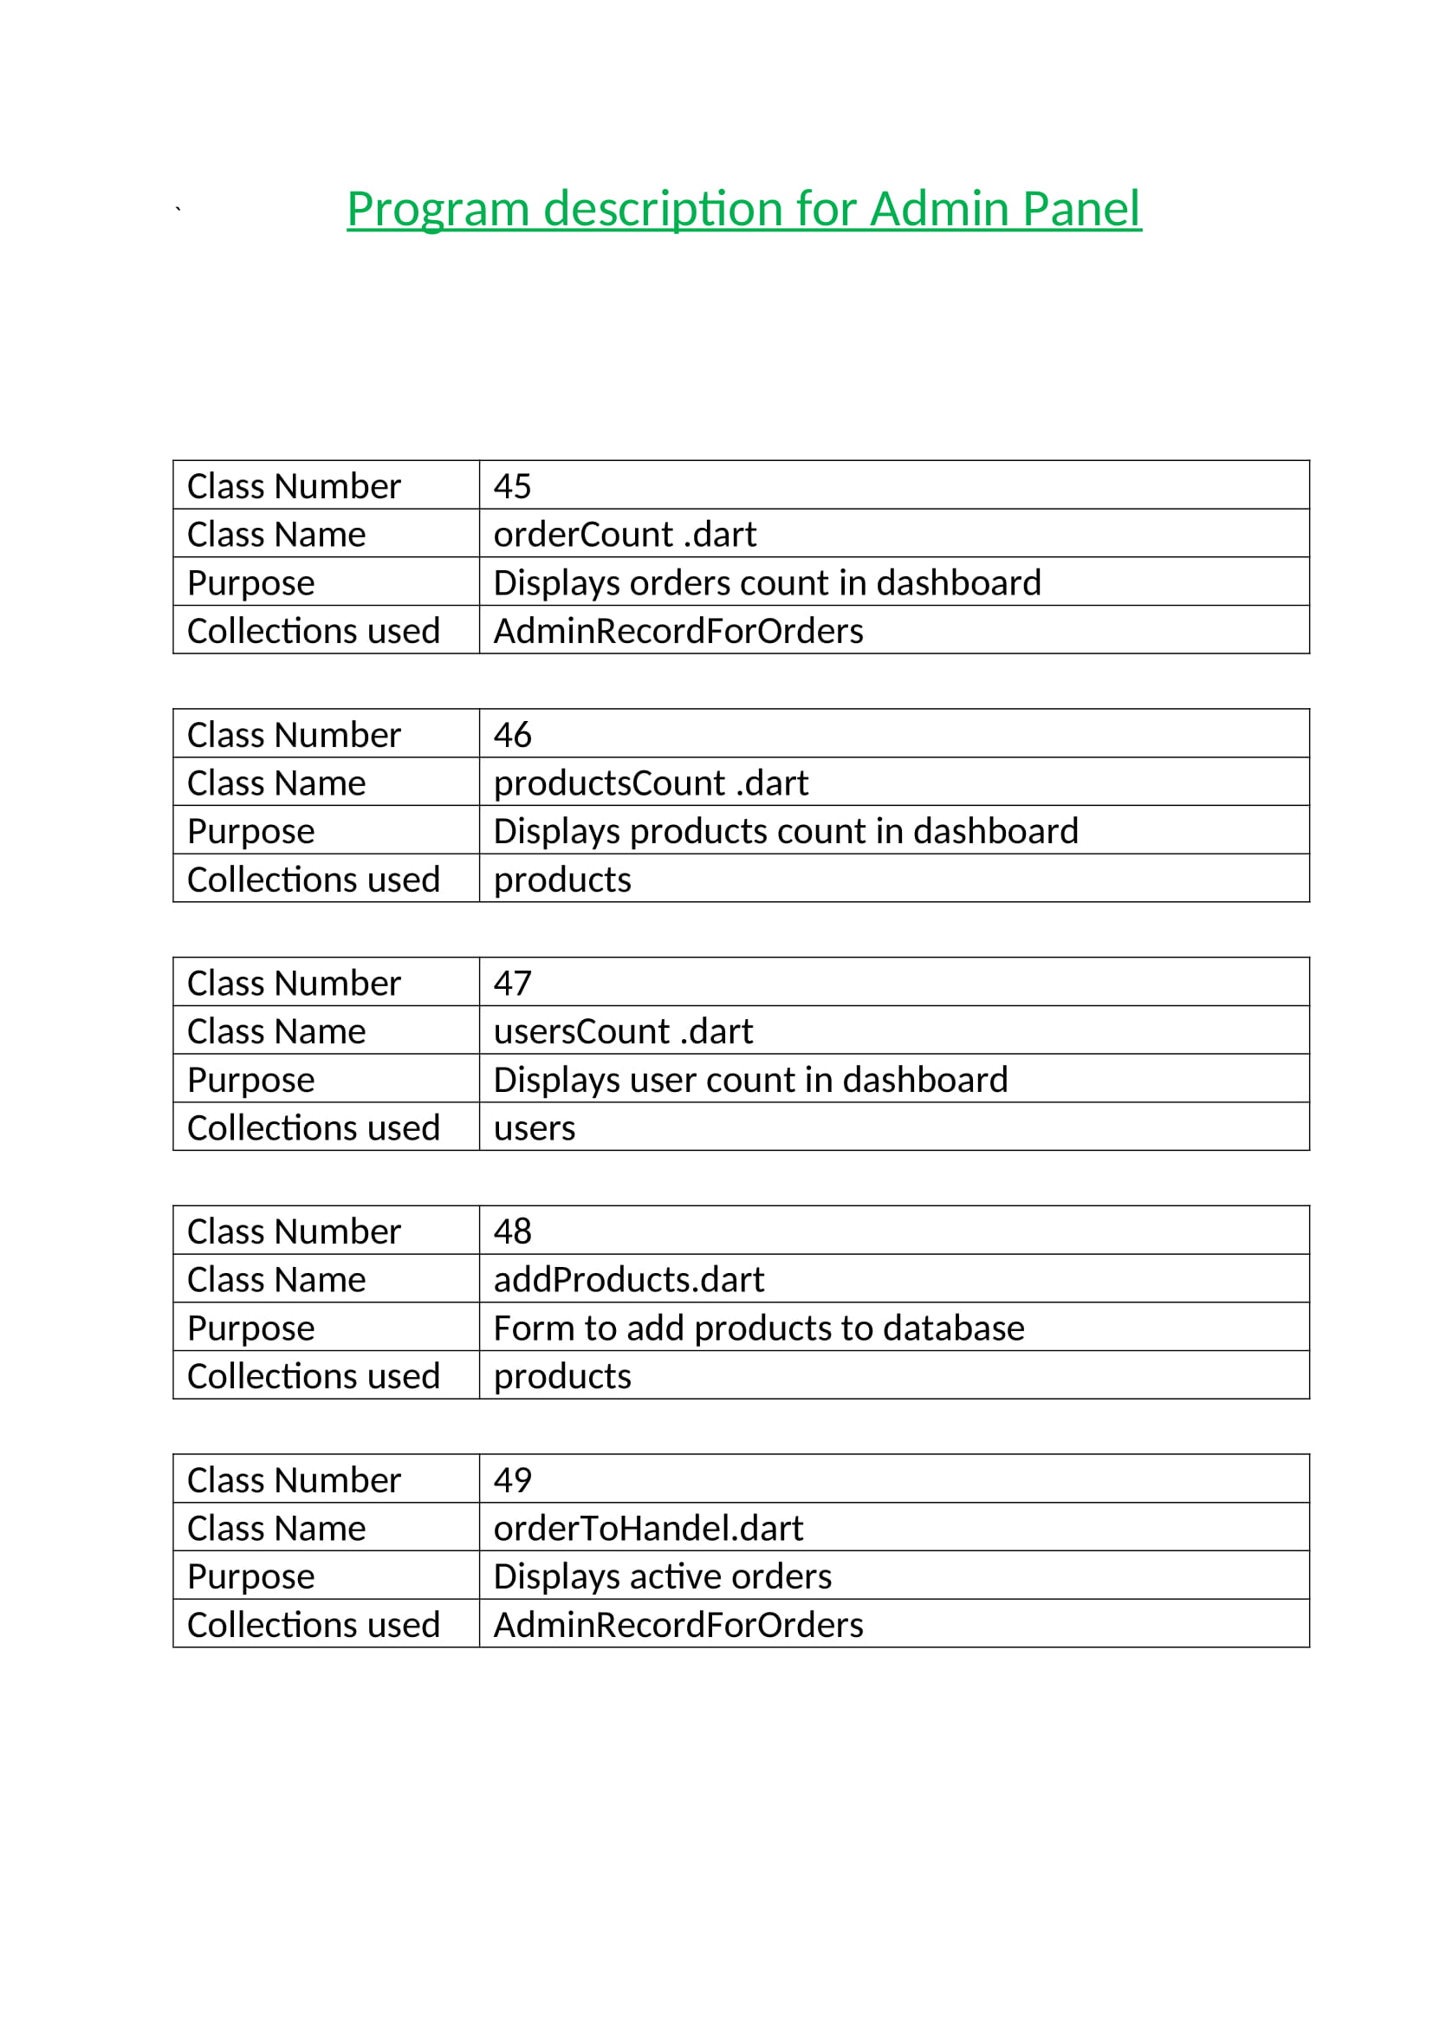

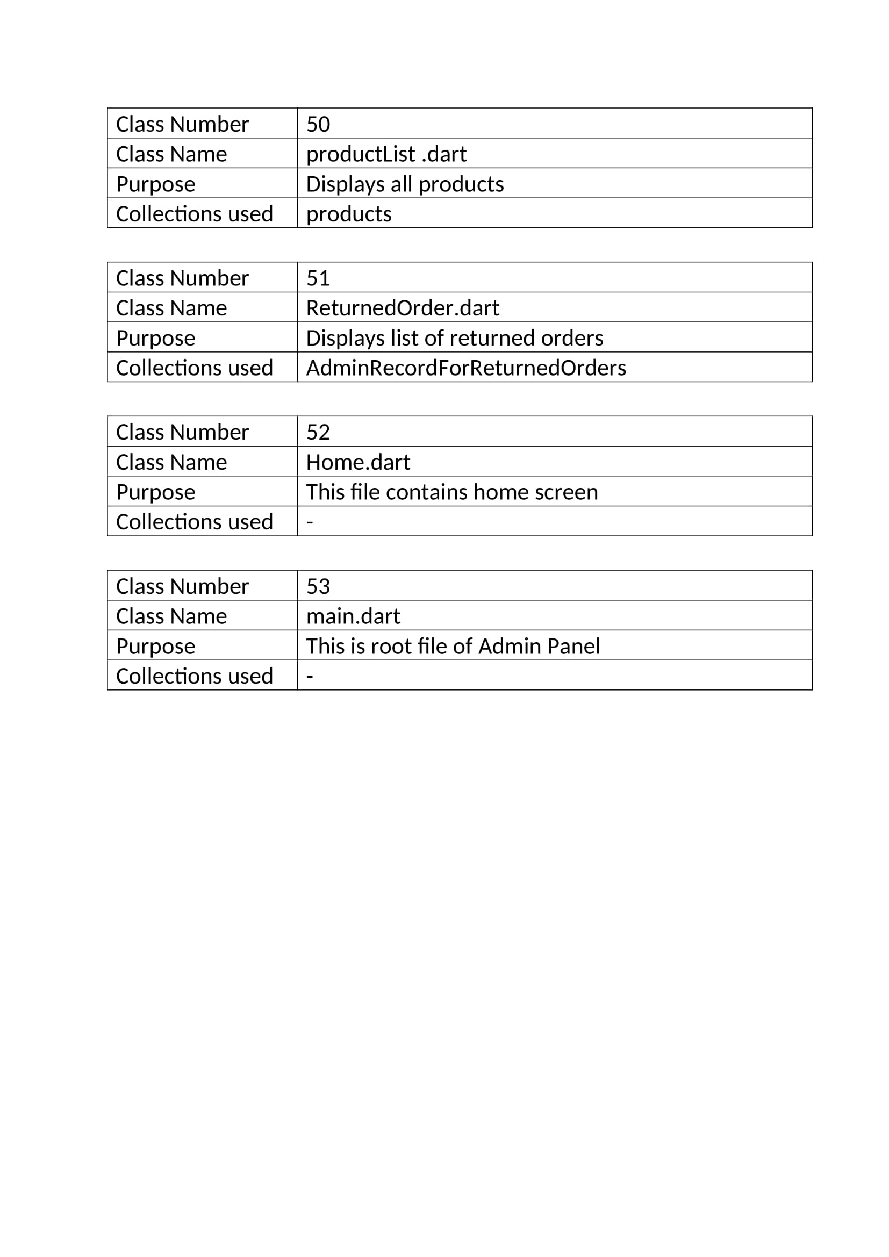

Screen Layouts

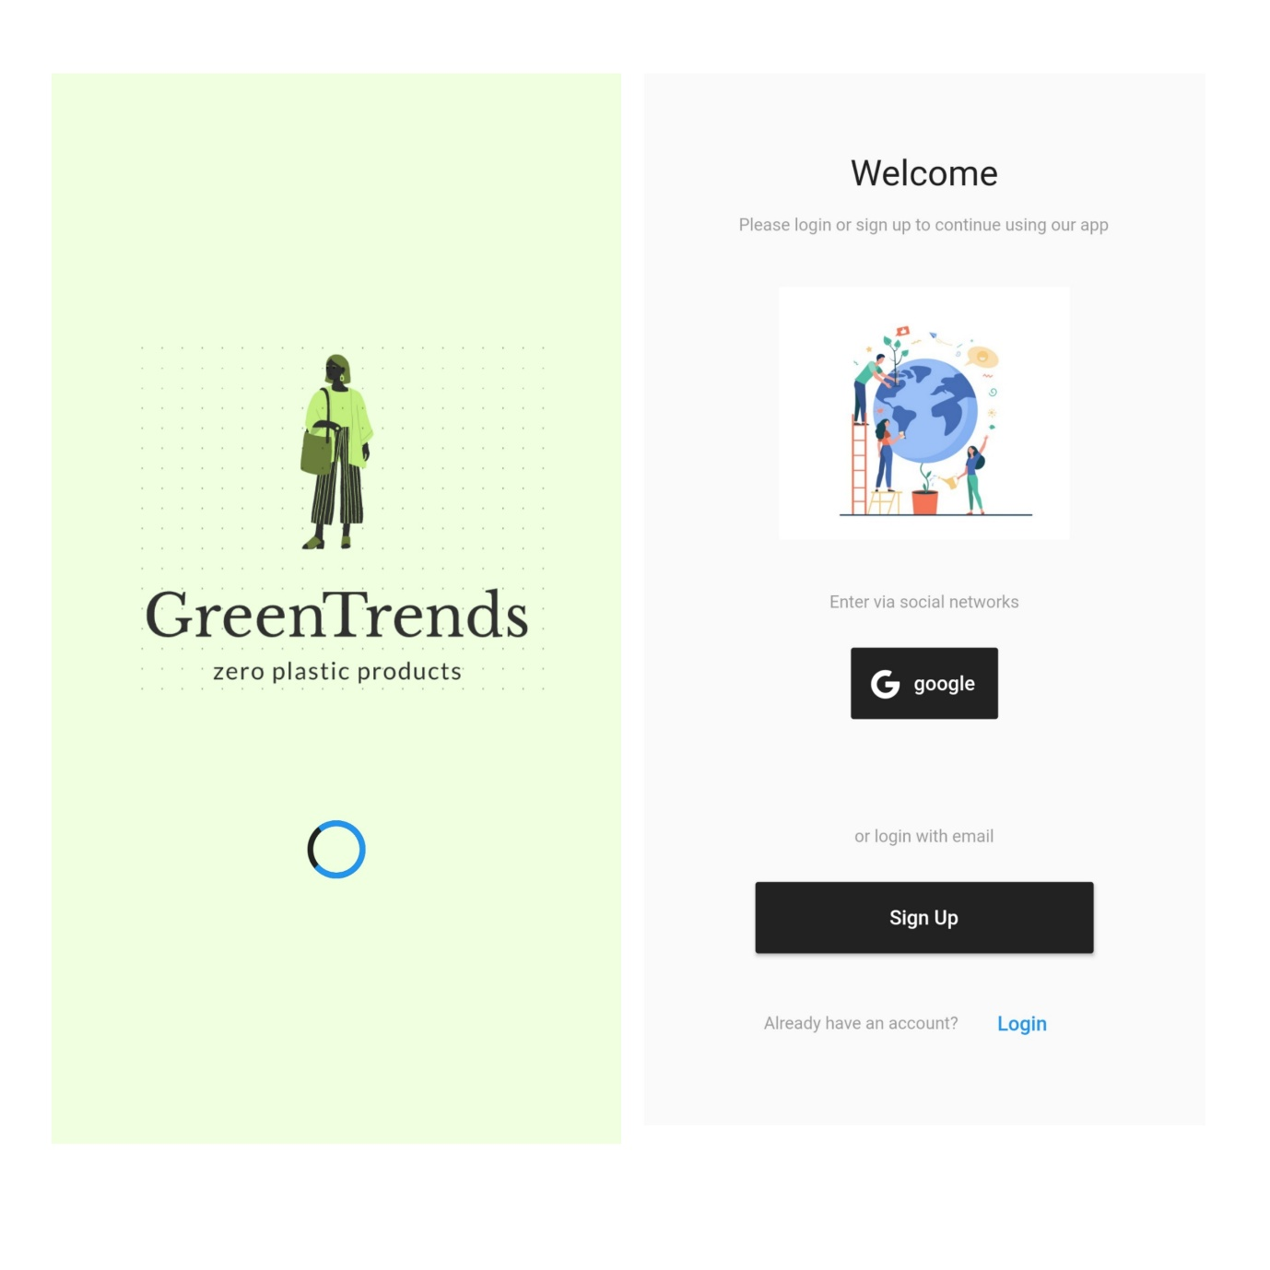

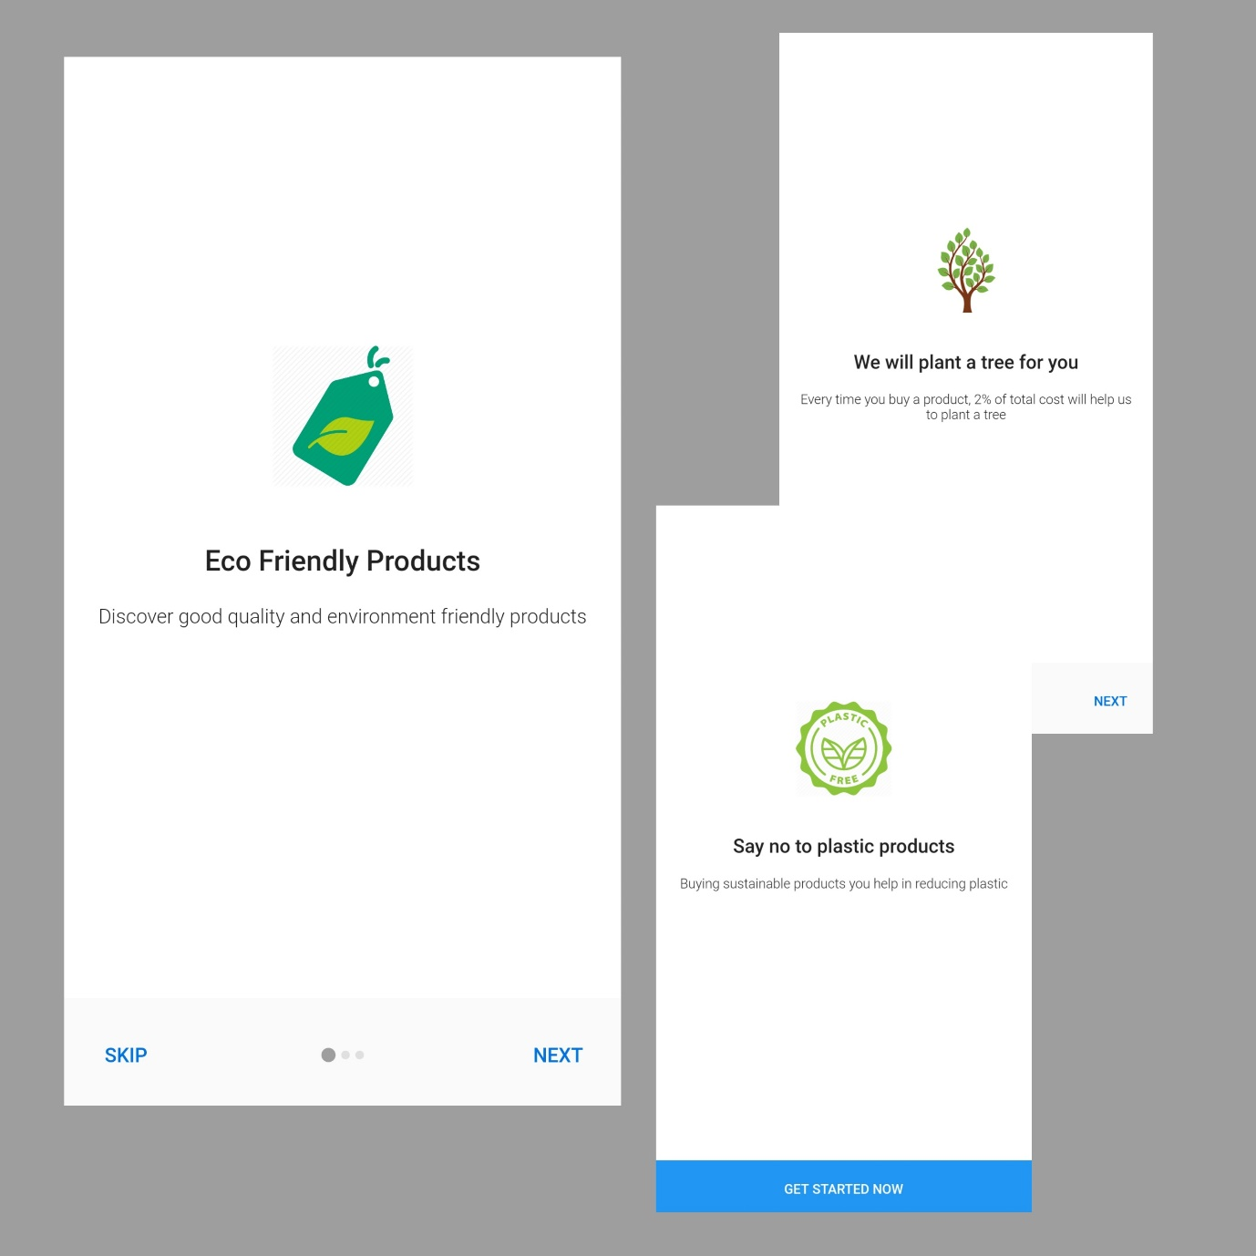



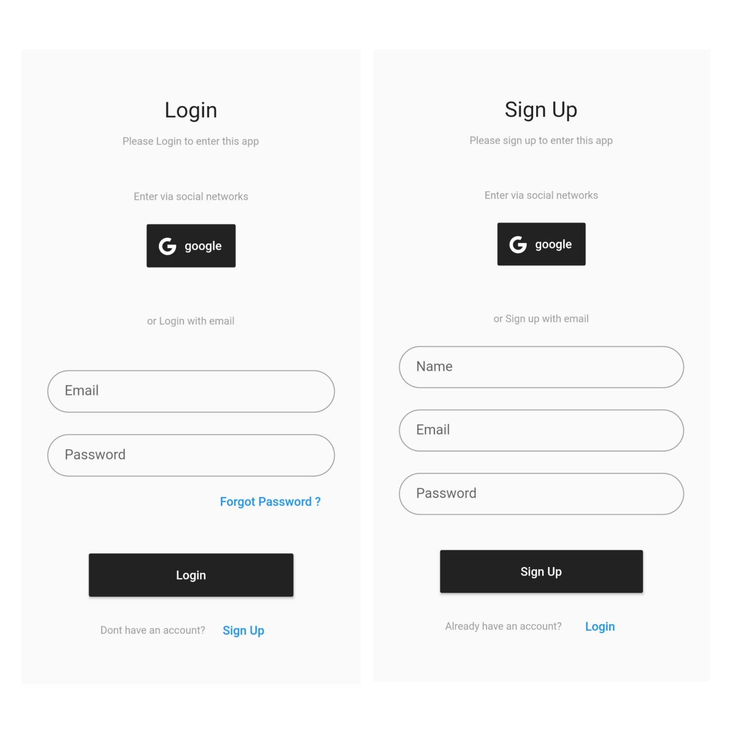

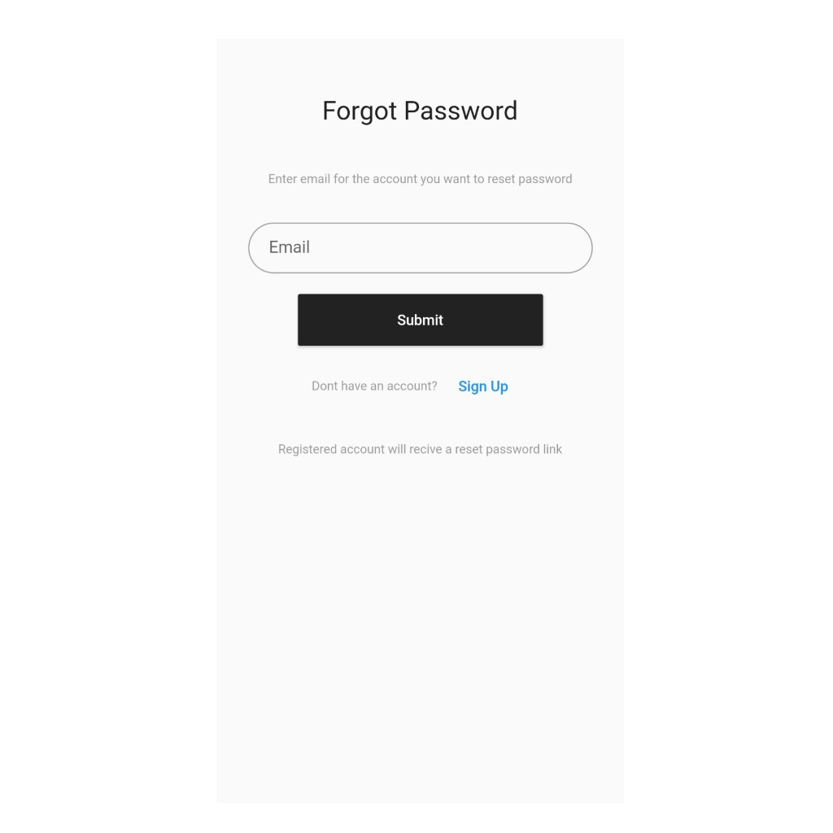

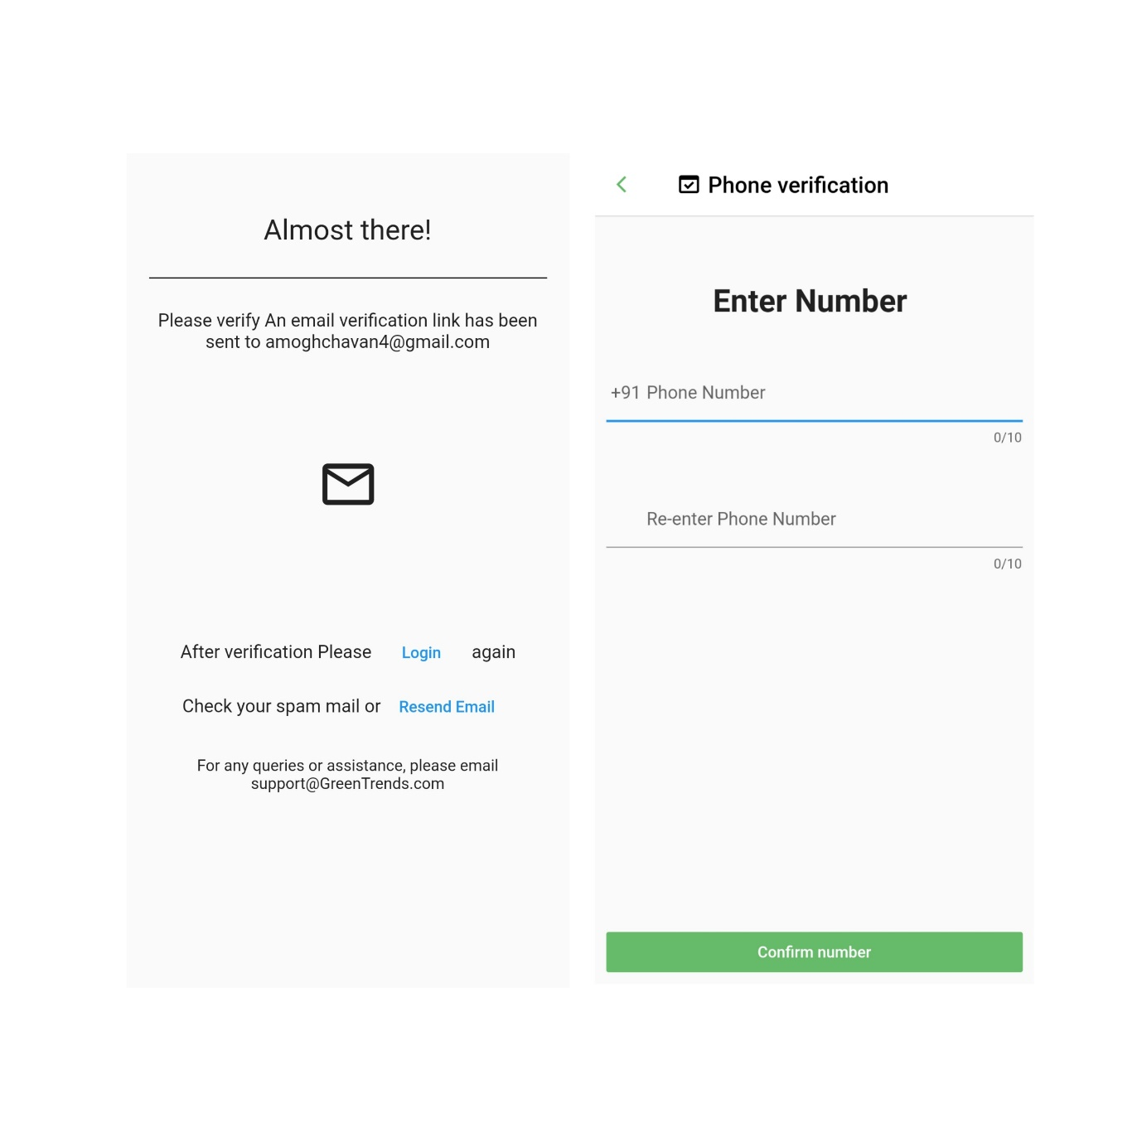

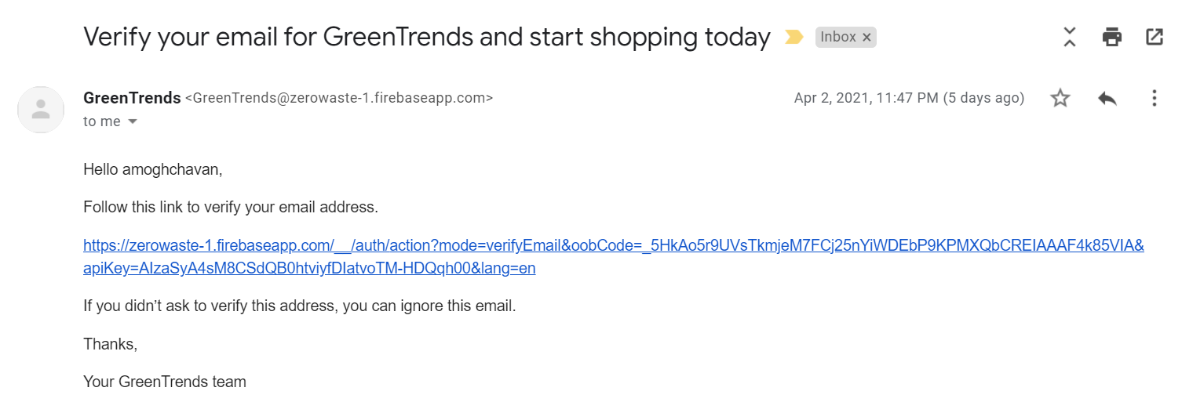

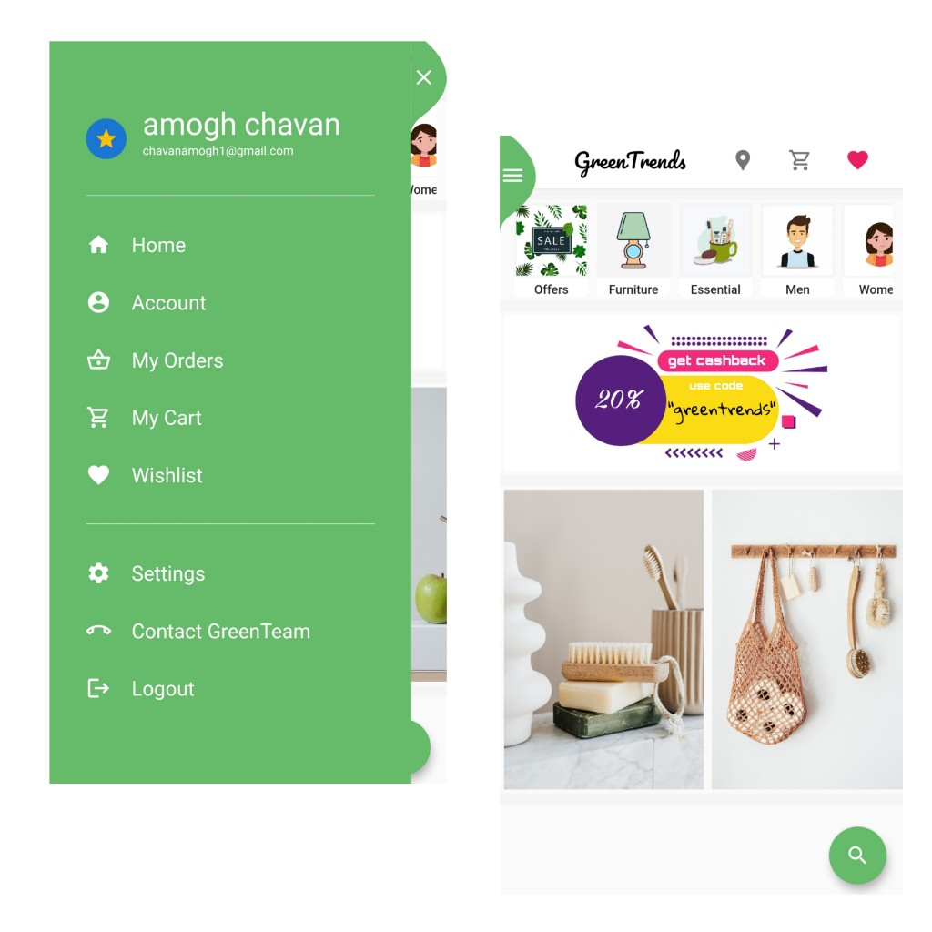

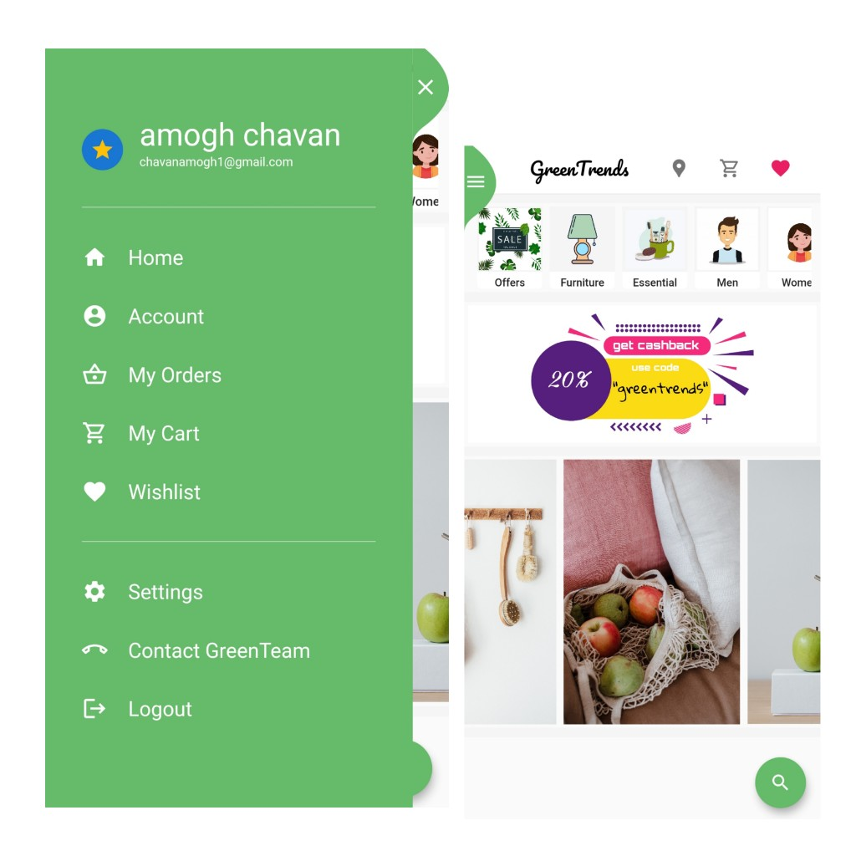

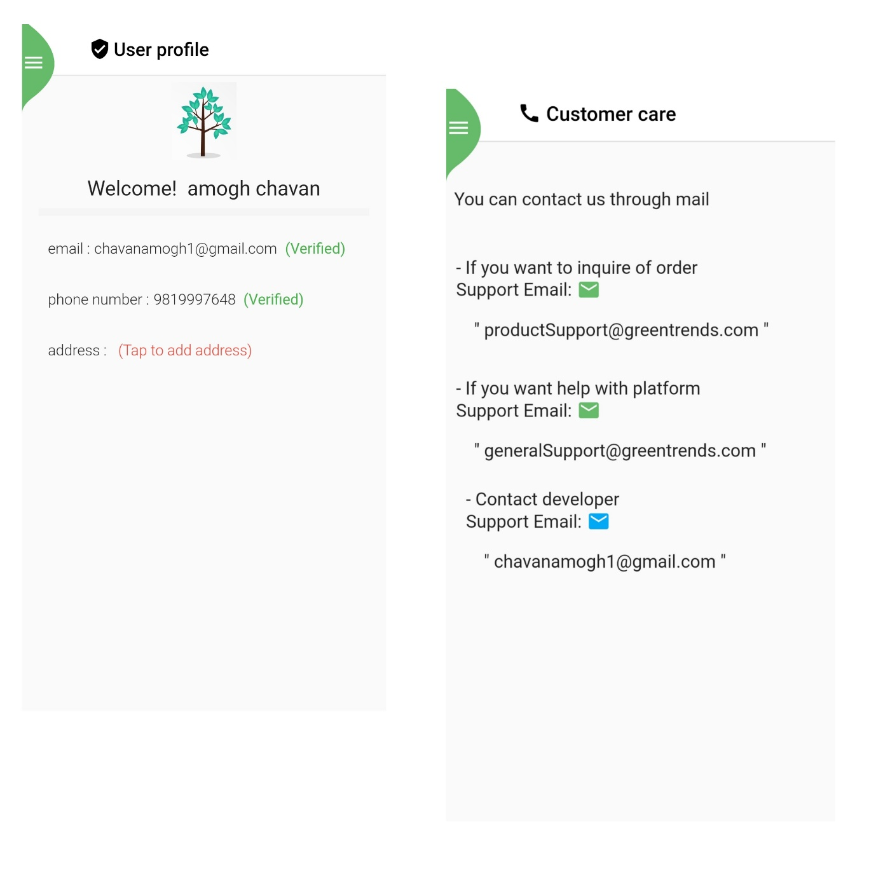

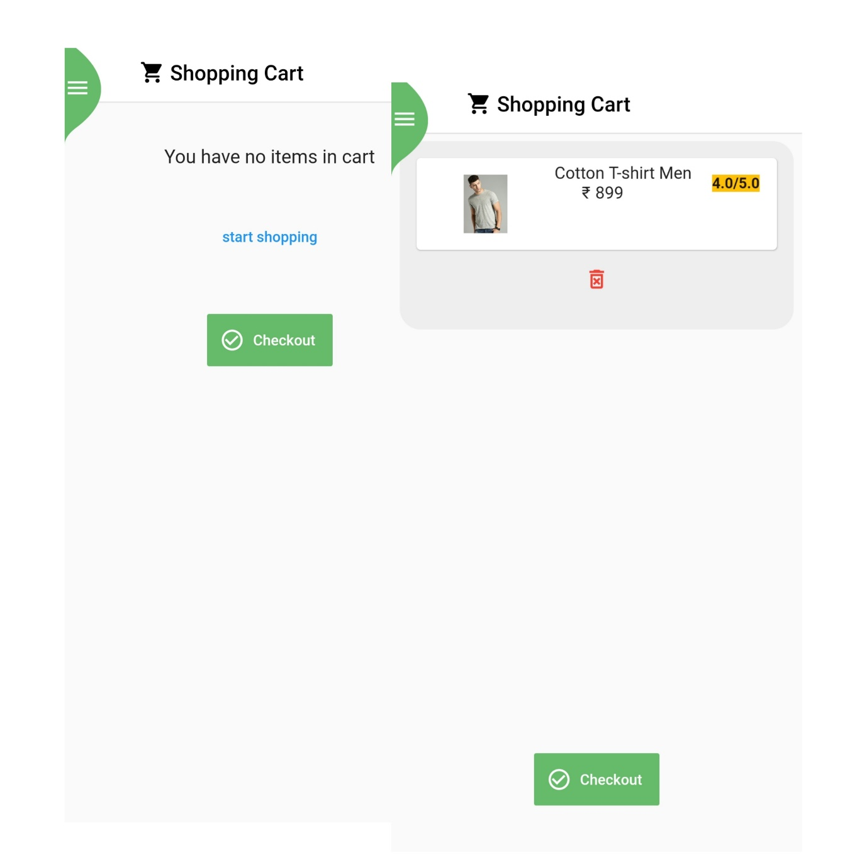

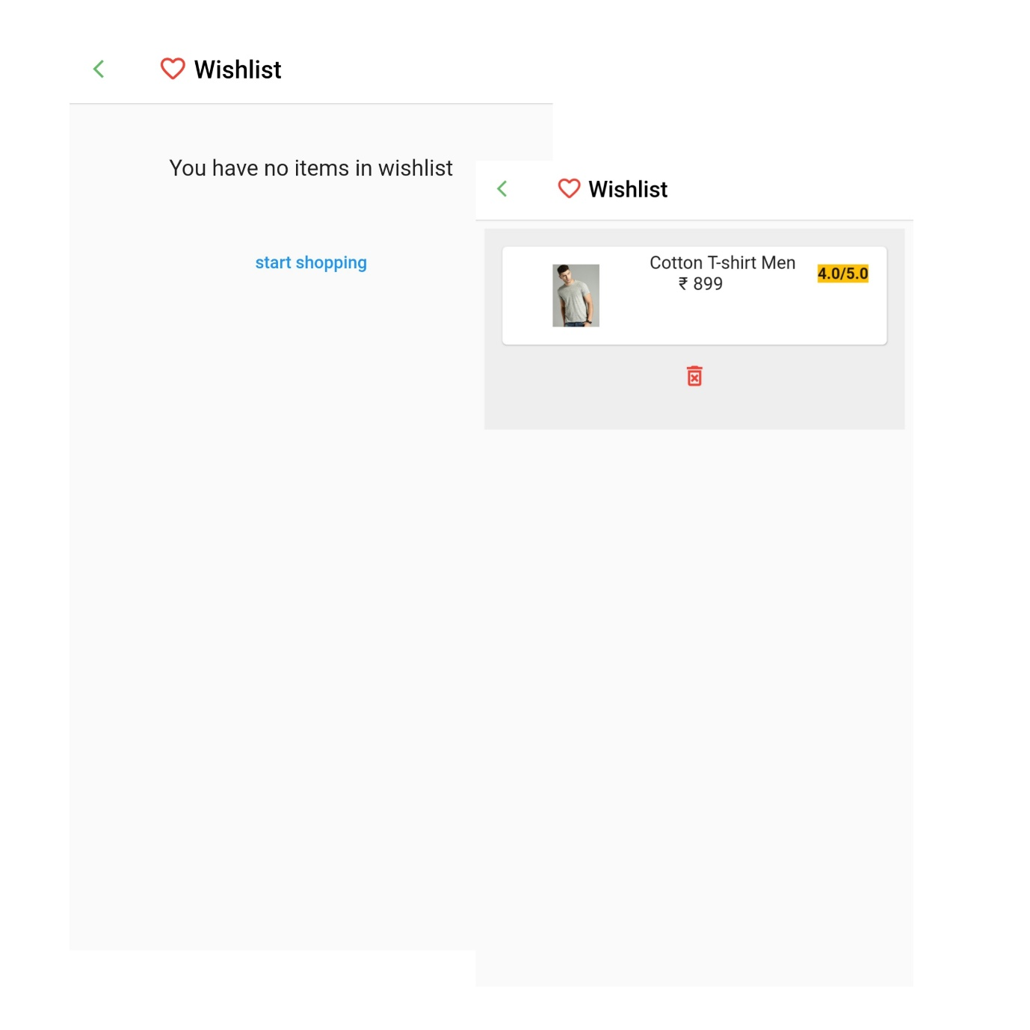

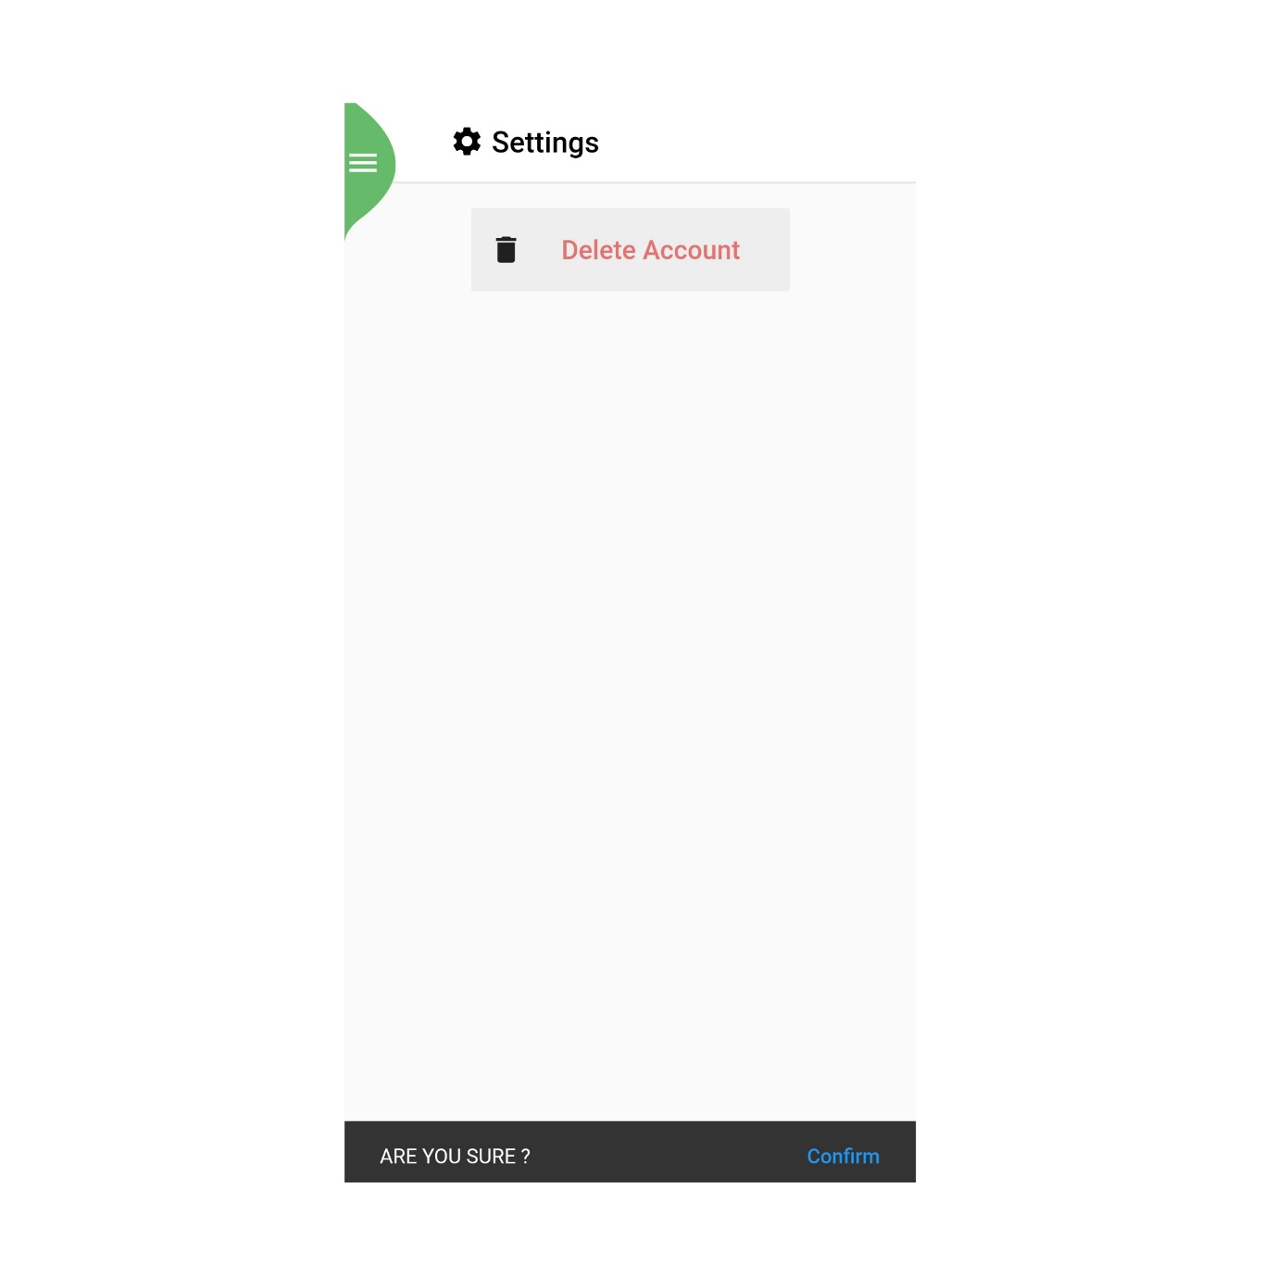

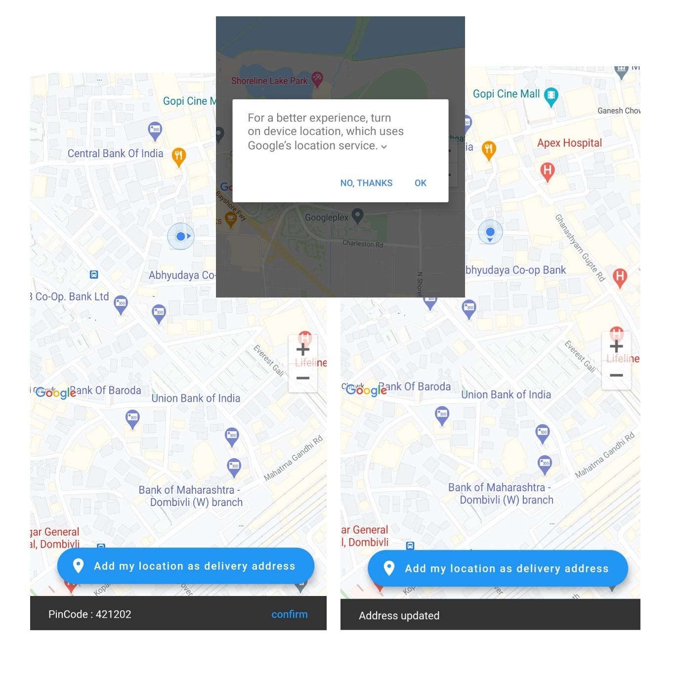

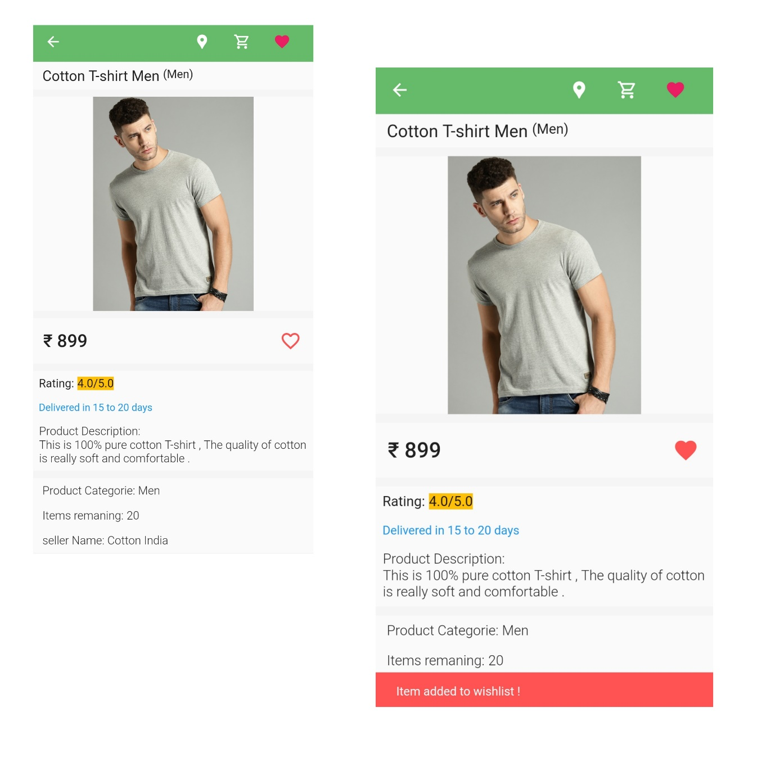



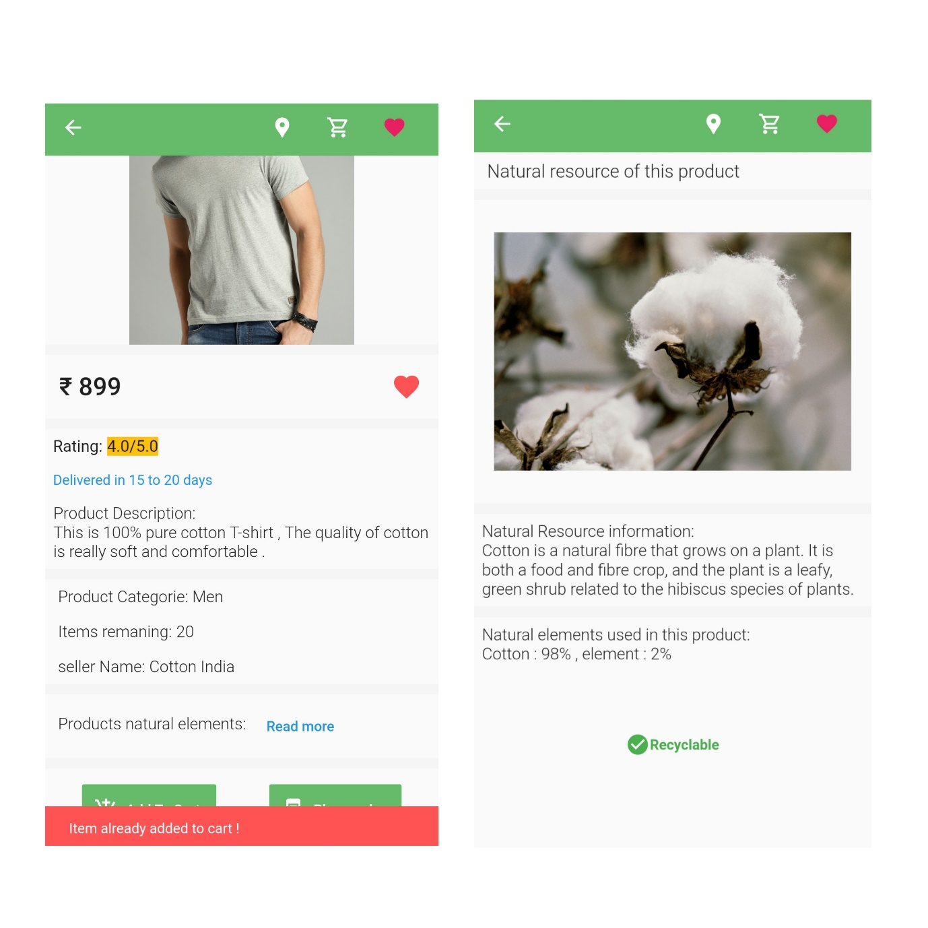

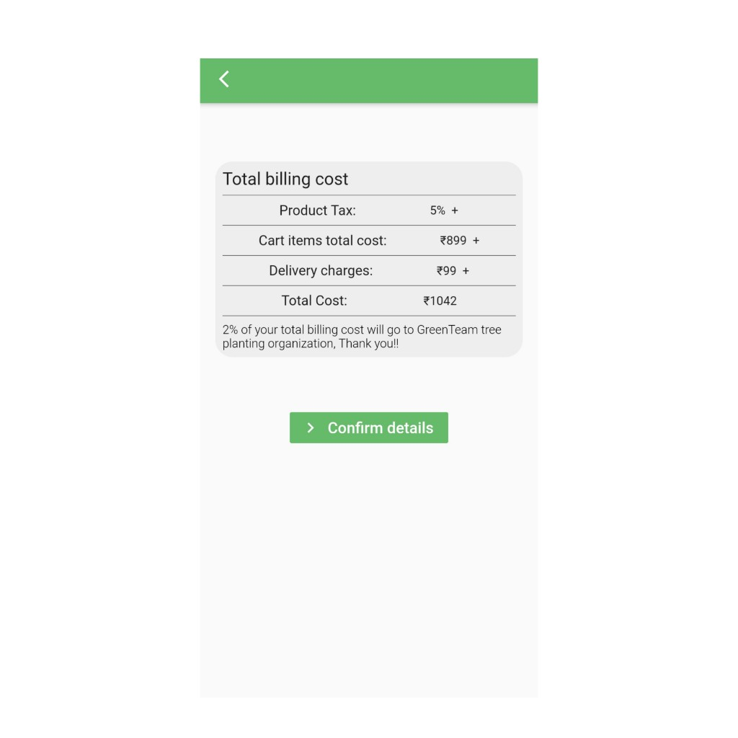

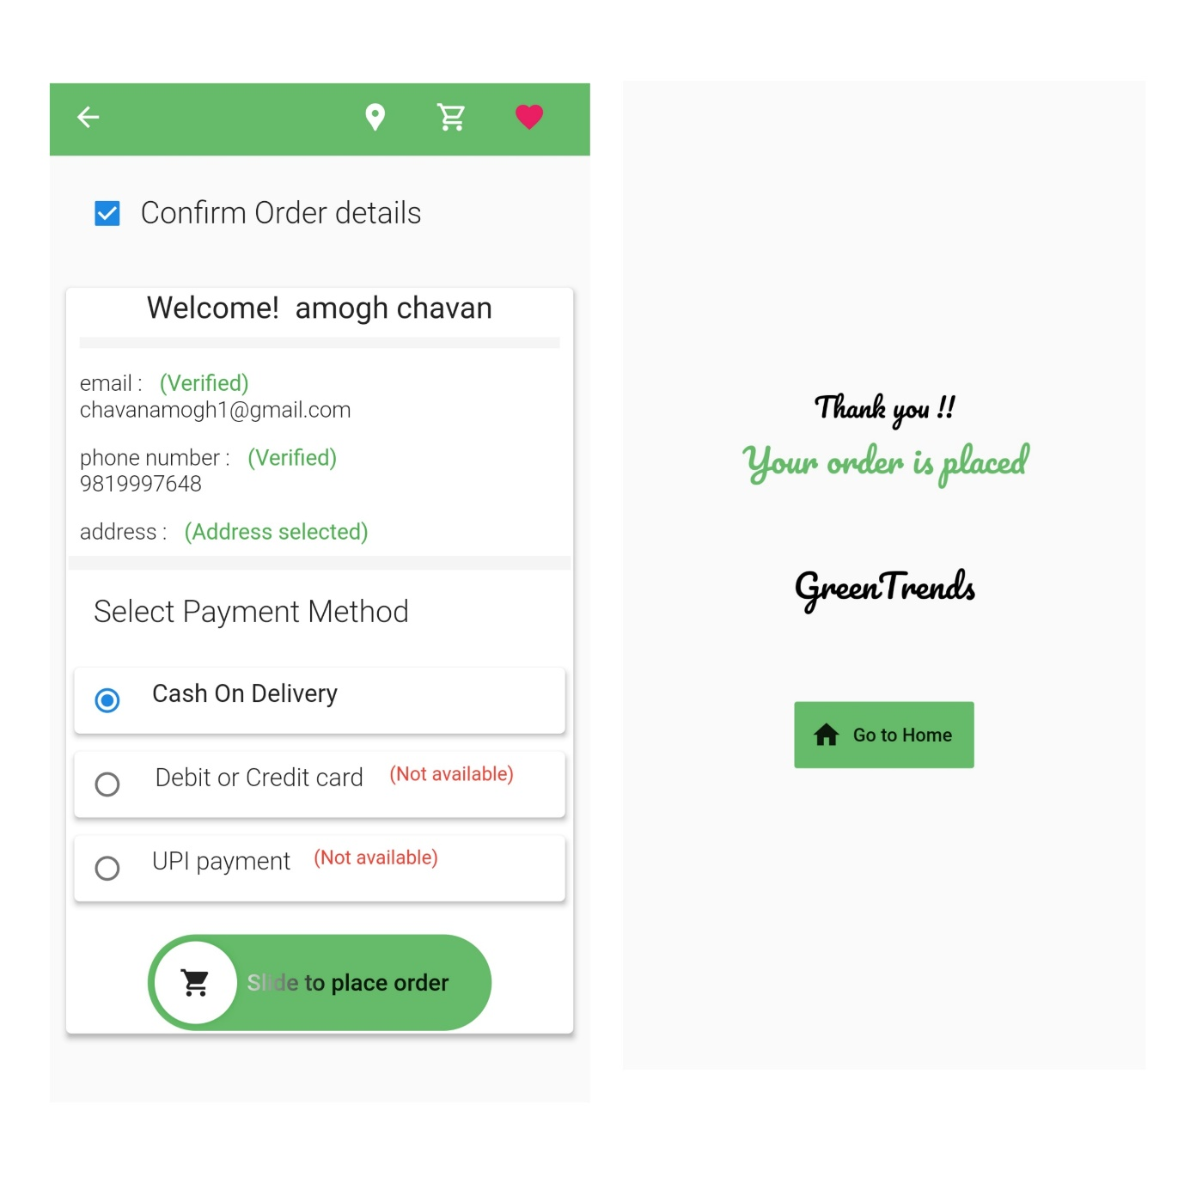

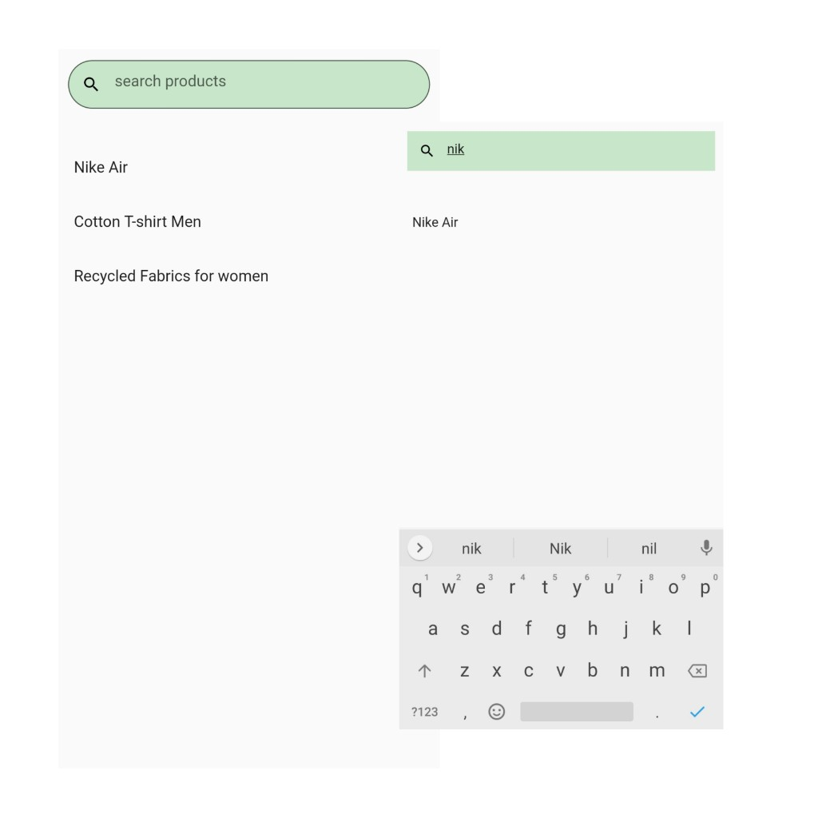

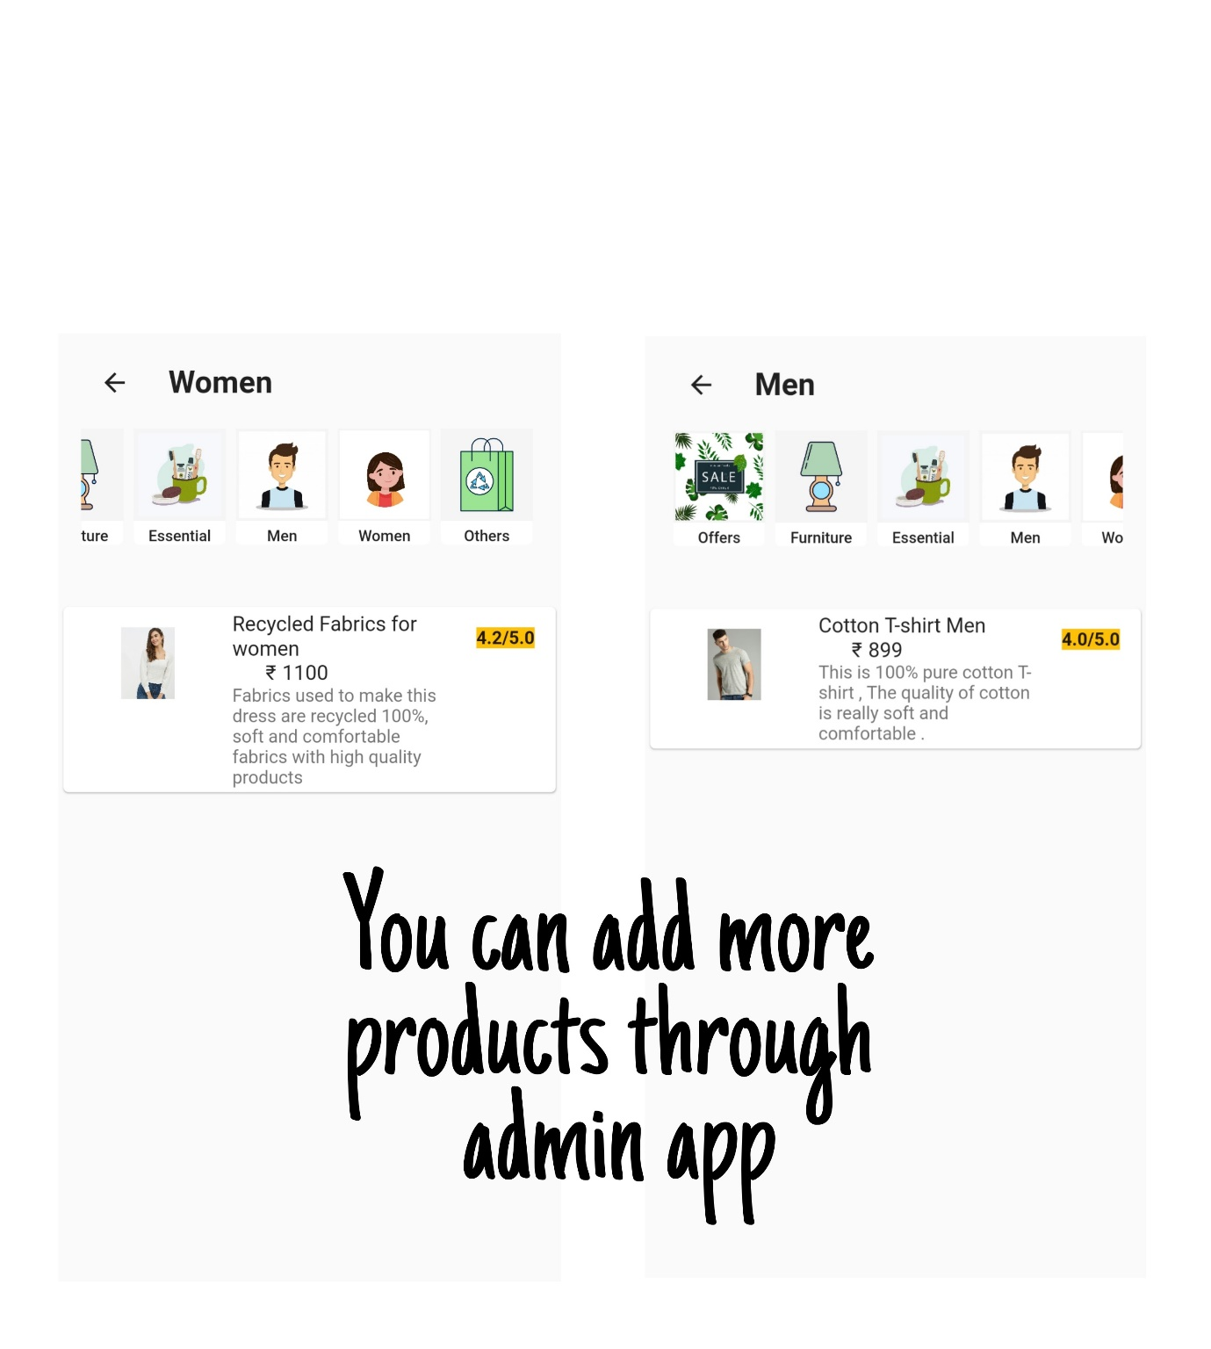

You can add more products from admin panel, for demo purpose we have on 1 product in each category.

Screen Layouts: Admin Panel

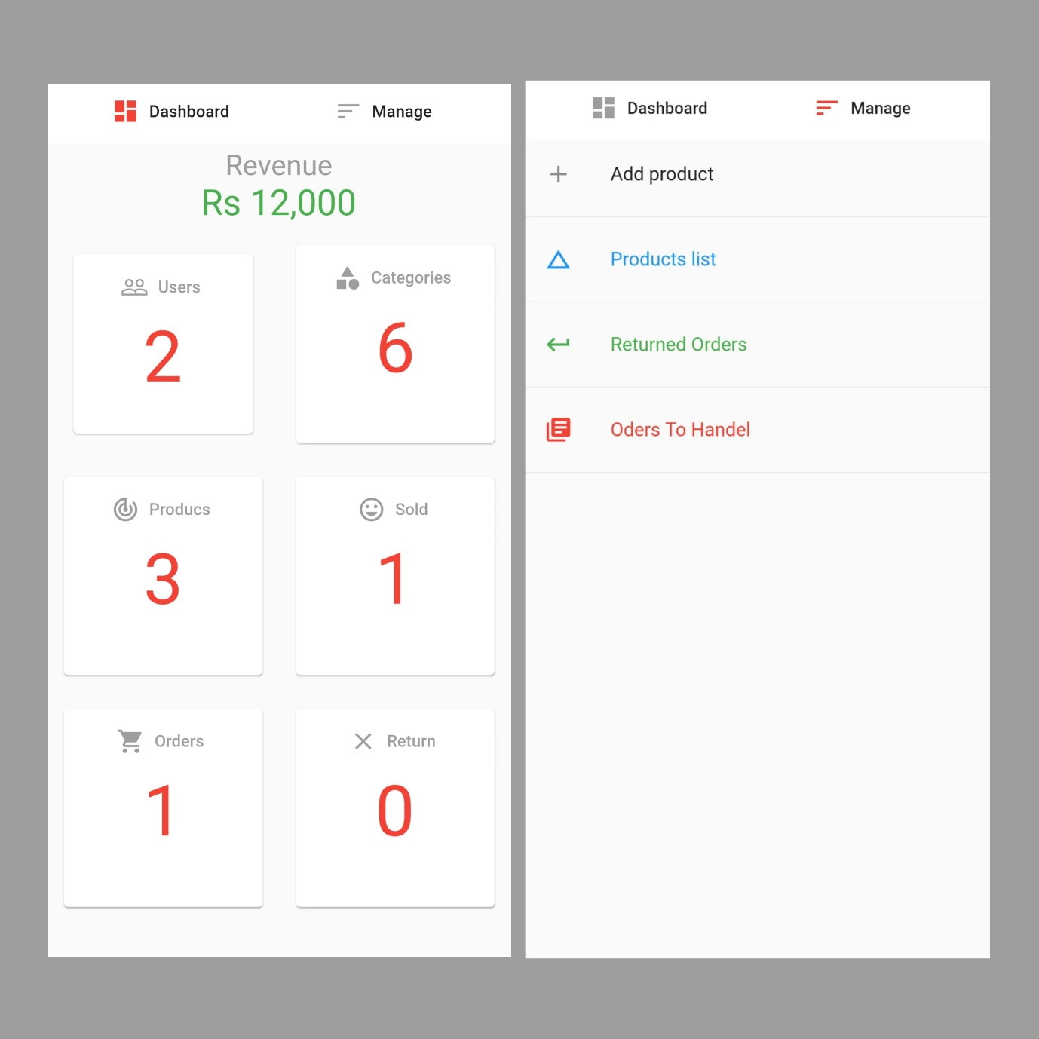

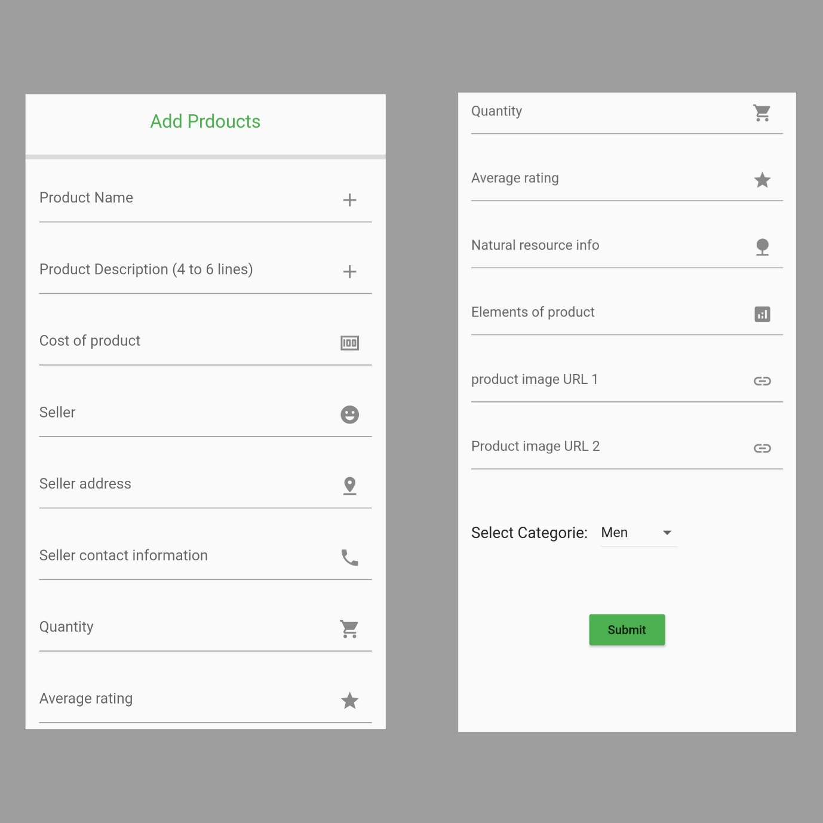

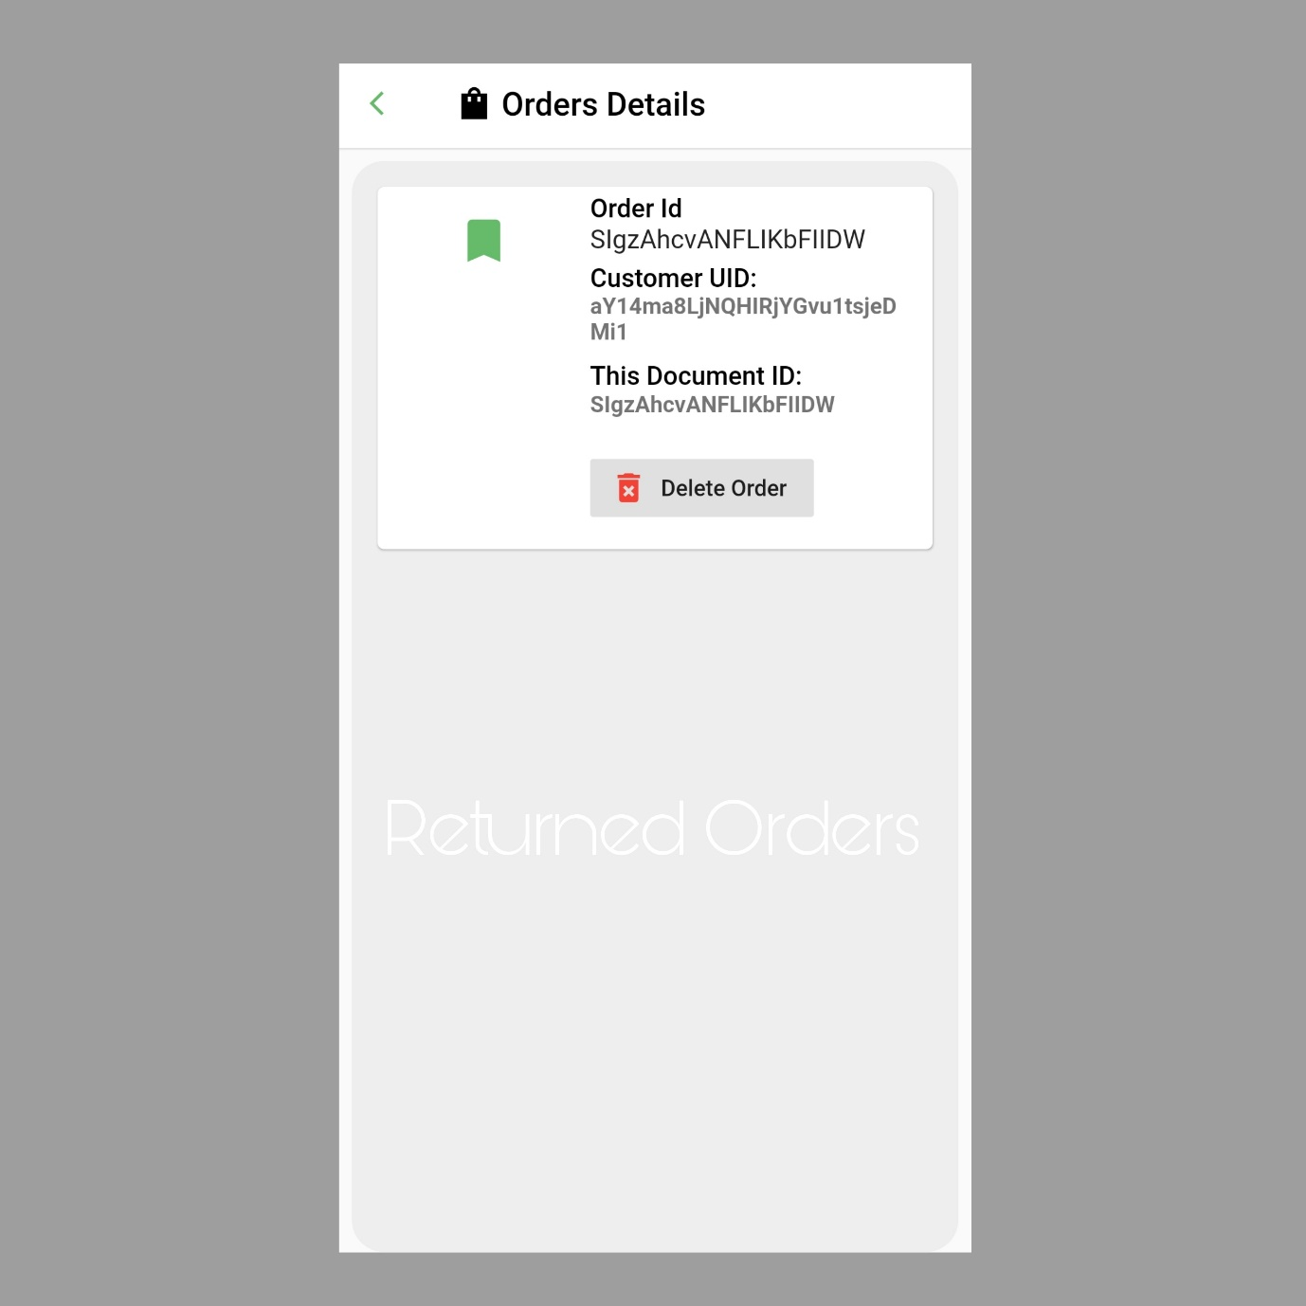

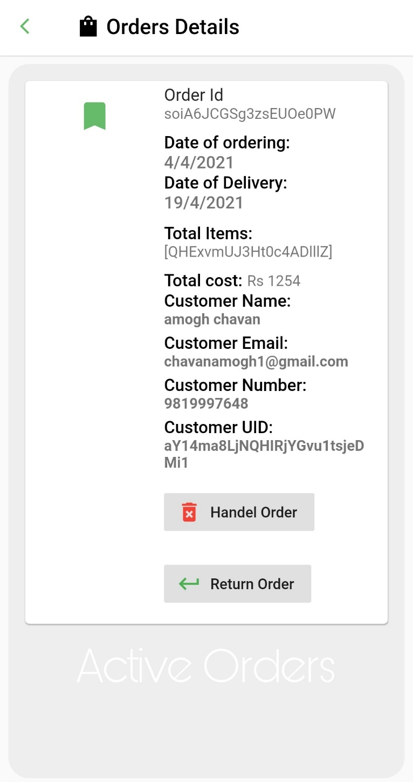

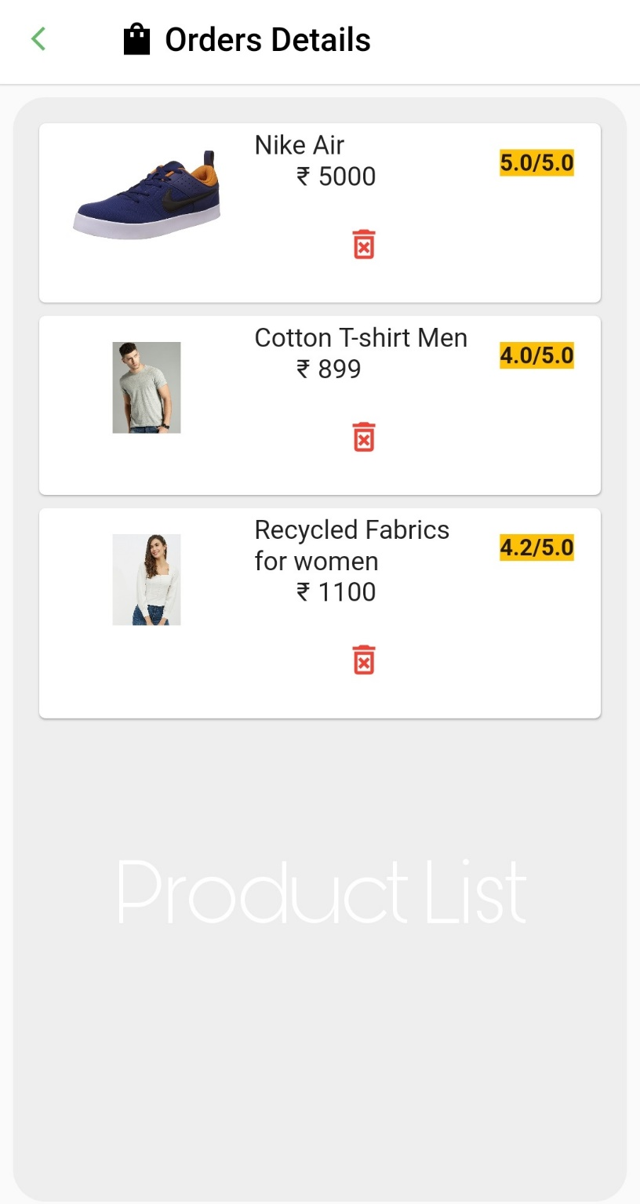

Validations

|  |  |  |  |  |  |
| --- | --- | --- | --- | --- | --- |
| Index | Test Case | Test Data | State | Test Input values | Result |
| 1. | To check an invalid email | Missing characters or invalid email format | Invalid | “amogh.com” | Invalid Email |
|  |  |  |  |  |  |
| 2. | To check valid email | Valid email format | Valid | “amogh@gmail.com” | Valid Email |
|  |  |  |  |  |  |
| 3. | To check already registered email | Valid email format | Invalid | “amogh@gmail.com” | Email Already registered |
|  |  |  |  |  |  |
| 4. | To check invalid phone number | Less number of digits in entered phone number | Invalid | “981999” | Incorrect phone number, please enter valid number |
|  |  |  |  |  |  |
| 5. | To check valid phone number | Valid number of digits in phone number | Valid | “9819998899” | Valid number |
|  |  |  |  |  |  |
|  |  |  |  |  |  |

UID and ID validations are performed all over the platform internally

Future Enhancement

* Any software product is not 100% complete, all software products need continuous future updates to fix bugs, add new features.
* For this project we can add some more options and features in future according to user response.
* We can add more payment options.
* We can improve and change backend admin panel if needed.
* We can add more backup collections in database to save any important data.

Thank you

Developer

* Amogh Chavan

Roll No: CS-3011

Division: 1

TYBSC Computer Science

Semester 6

College: DG Ruparel College

UIN: 1833611

PRN / Registration Number: 2018016401451601